|  |
| --- |
| **Phase-3**  **Implement Frameworks the DevOps way**  **Project :-Make an E-commerce Website**  **for**  **Sporty Shoes**  **(Application Screenshots)** |

**Version History**

|  |  |
| --- | --- |
| Author | K.Swathi |
| Purpose | Screenshots of the Application |
| Date | 07/10/2021 |

**Screenshots – Project Explorer**

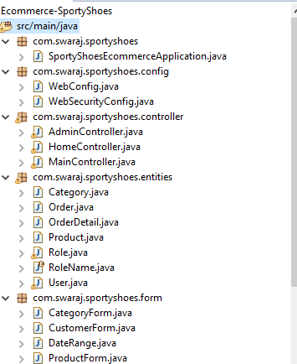

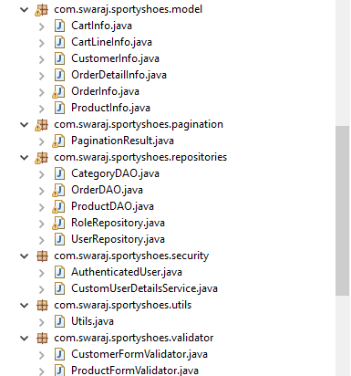

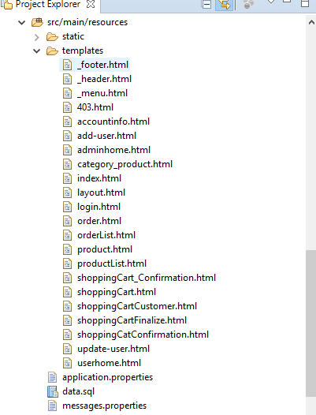

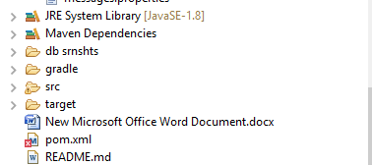

**Main Folder 🡪 To create a new Project 🡪 package🡪 EcommerceSportyShoes🡪**

**Src/main/java**

**1)com.swaraj.sportyshoes**

**🡪SportyShoesEcommerceApplication.java**

**2)com.swaraj.sportyshoes.config**

**🡪webconfig.java**

**🡪websecurityconfig.java**

**3) com.swaraj.sportyshoes.controller**

**🡪AdminController.java**

**🡪HomeController.java**

**🡪MainController.java**

**4) com.swaraj.sportyshoes.entities**

**🡪Category.java**

**🡪Order.java**

**🡪OrderDetail.java**

**🡪Product.java**

**🡪Role.java**

**🡪RoleName.java**

**🡪User.java**

**5)com.swaraj.sportyshoes.form**

**🡪CategoryForm.java**

**🡪CustomerForm.java**

**🡪DataRange.java**

**🡪ProductForm.java**

**6) com.swaraj.sportyshoes.model**

**🡪CartInfo.java**

**🡪CartLineInfo.java**

**🡪CustomerInfo.java**

**🡪OrderDetailInfo.java**

**🡪OrderInfo.java**

**🡪ProductInfo.java**

**7) com.swaraj.sportyshoes.pagination**

**🡪PaginationResult.java**

**8) com.swaraj.sportyshoes.repositories**

**🡪CatogoryDAO.java**

**🡪OrderDAO.java**

**🡪ProductDAO.java**

**🡪RoleRepository.java**

**🡪UserRepository.java**

**9) com.swaraj.sportyshoes.security**

**🡪AuthenticatedUser.java**

**🡪CustomUserDetailsService.java**

**10) com.swaraj.sportyshoes.utils**

**🡪Utils.java**

**11) com.swaraj.sportyshoes.validotor**

**🡪CustomerFormValidator.java**

**🡪ProductFormValidator.java**

**Main Folder 🡪 To create a new Project 🡪 package🡪 EcommerceSportyShoes🡪**

**Src/main/resources**

**1)error**

**🡪403.html**

**🡪daterangepicker.css**

**🡪Style.css**

**2)templates**

**🡪footer.html**

**🡪header.html**

**🡪menu.html**

**🡪403.html**

**🡪accountinfo.html**

**🡪add-user.html**

**🡪adminhome.html**

**🡪category-product.html**

**🡪index.html**

**🡪layout.html**

**🡪login.html**

**🡪order.html**

**🡪orderlist.html**

**🡪product.html**

**🡪 productlist.html**

**🡪shoppingCartConfirmation.html**

**🡪ShoppingCart.html**

**🡪shoppingcartCustomer.html**

**🡪shoppingcartFinalize.html**

**🡪updateuser.html**

**🡪userhome.html**

**🡪application.properties**

**🡪data.sql**

**🡪message.properties**

**Sourcecode-Screenshots:-**

**Main Folder 🡪 To create a new Project 🡪 package🡪 EcommerceSportyShoes🡪**

**Src/main/java**

**1)com.swaraj.sportyshoes**

**🡪SportyShoesEcommerceApplication.java**

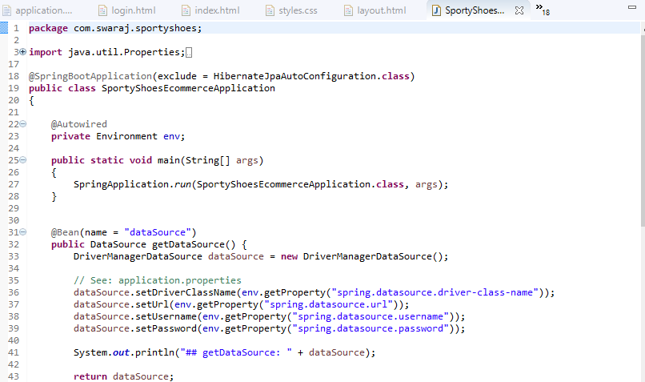

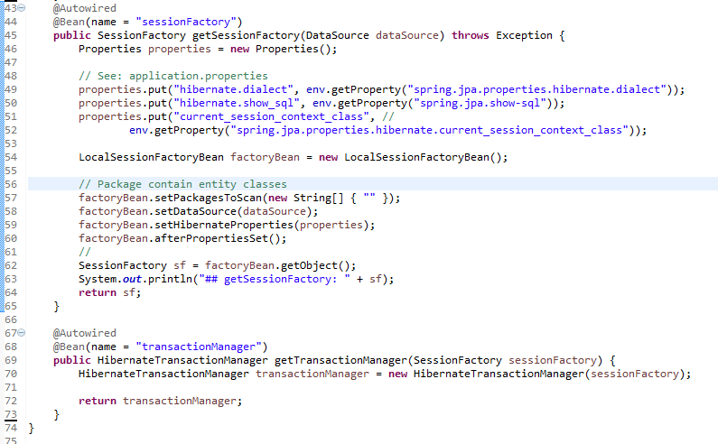

**2)com.swaraj.sportyshoes.config**

**🡪webconfig.java**

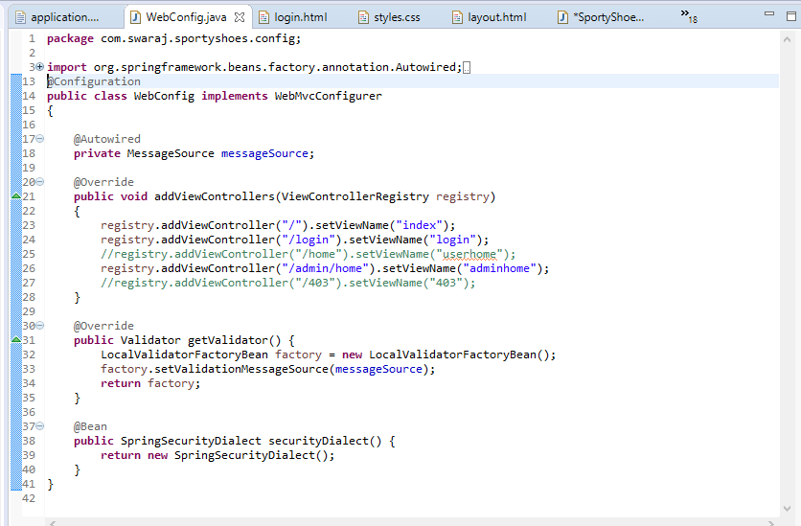

**🡪websecurityconfig.java**

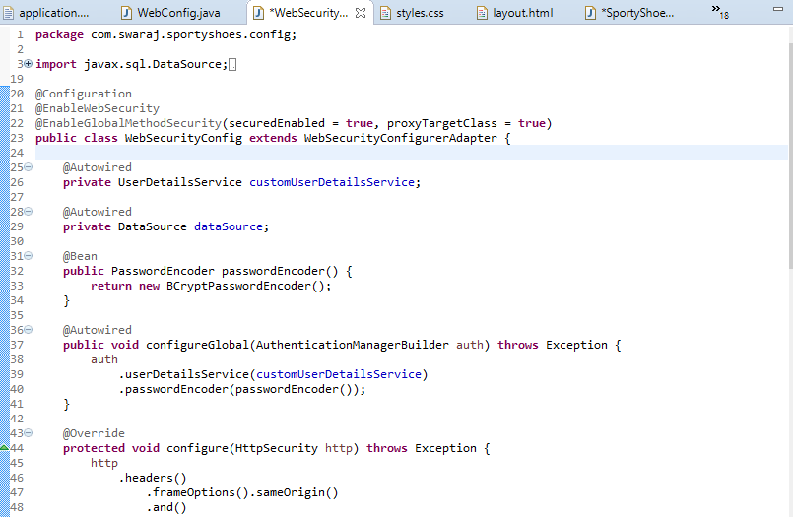

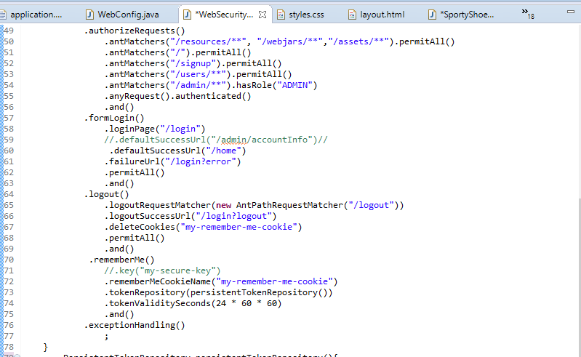

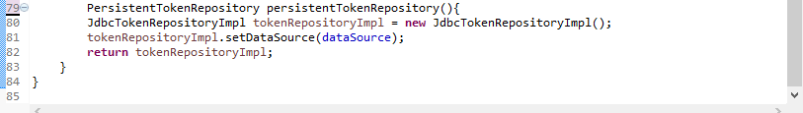

**3) com.swaraj.sportyshoes.controller**

**🡪AdminController.java**

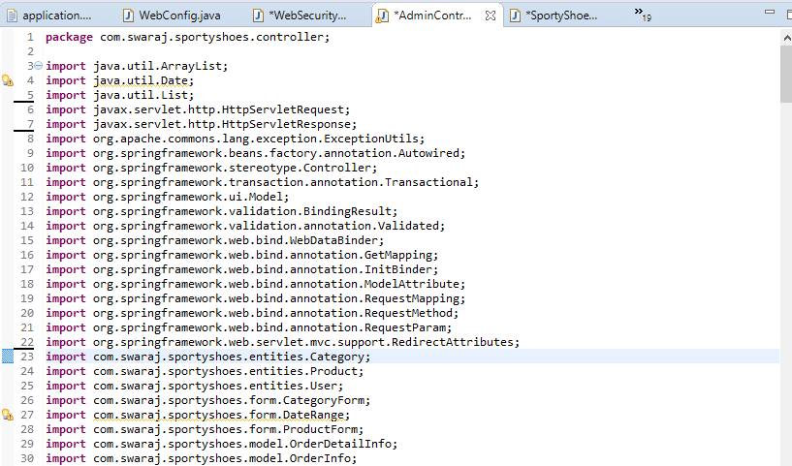

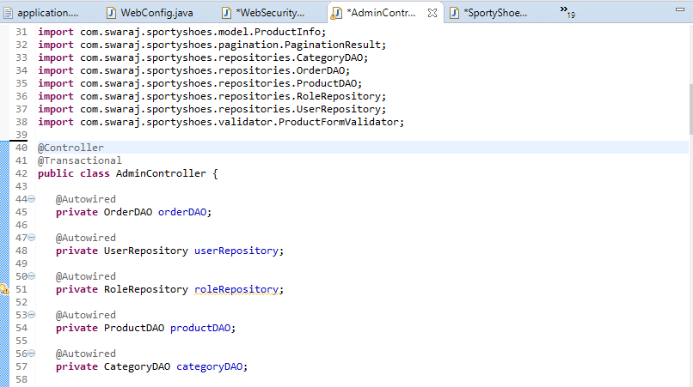

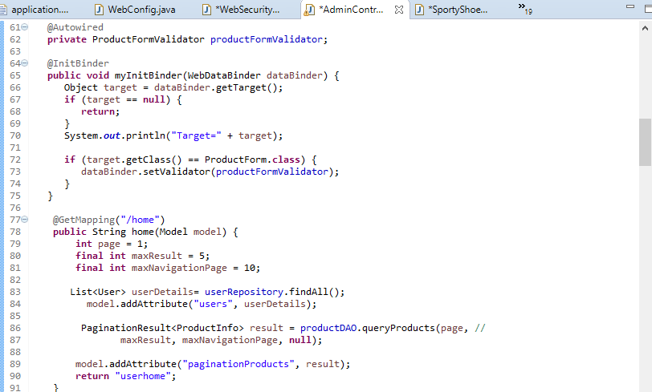

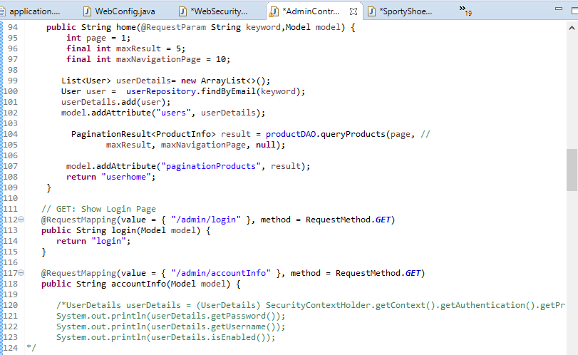

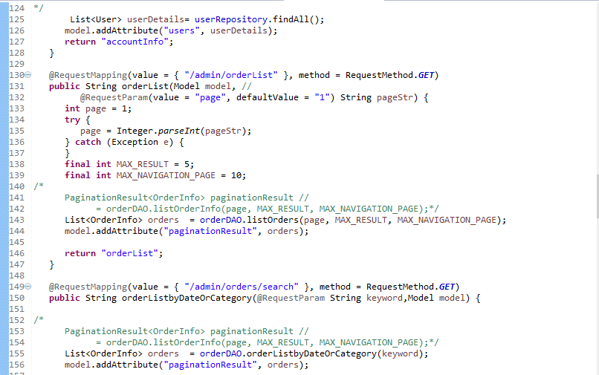

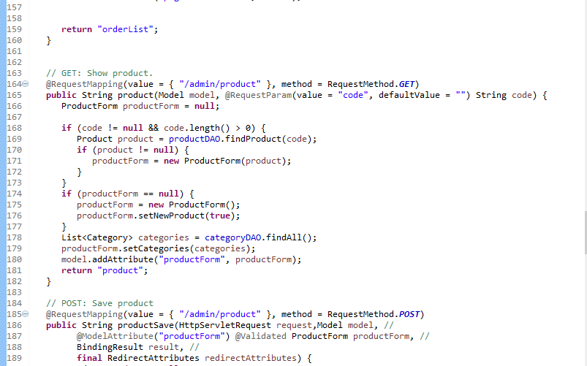

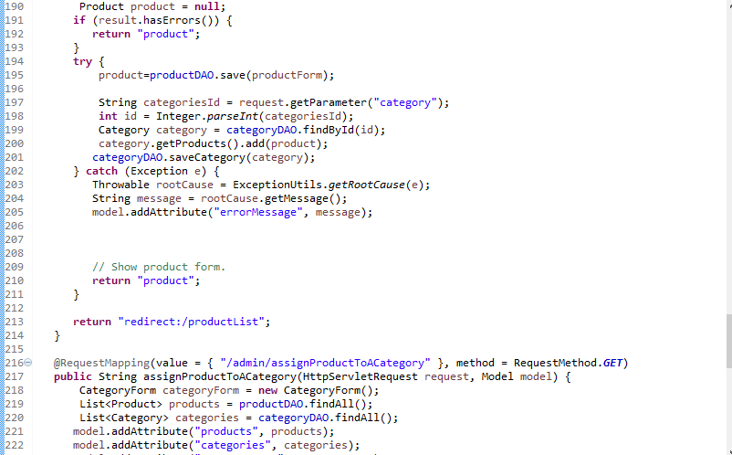

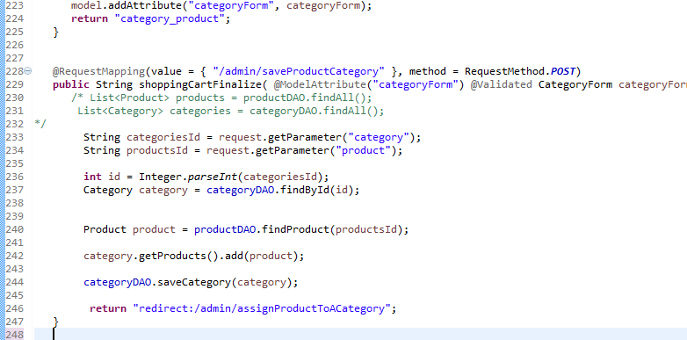

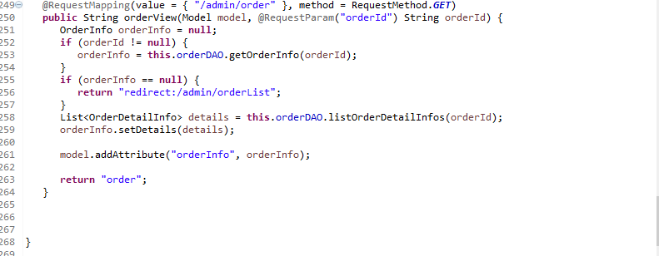

**🡪HomeController.java**

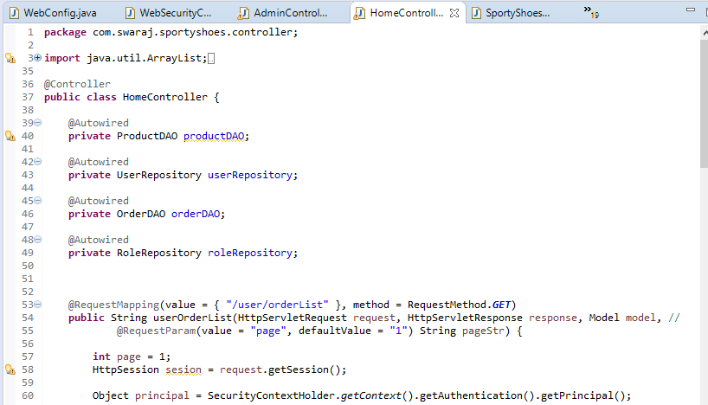

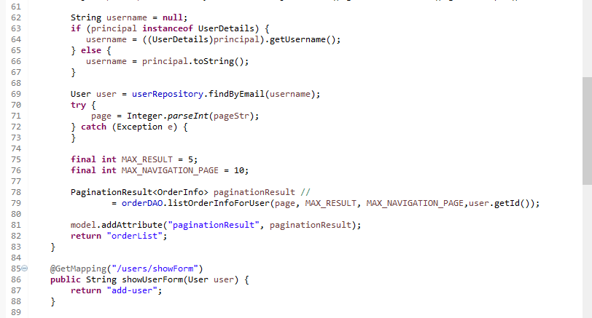

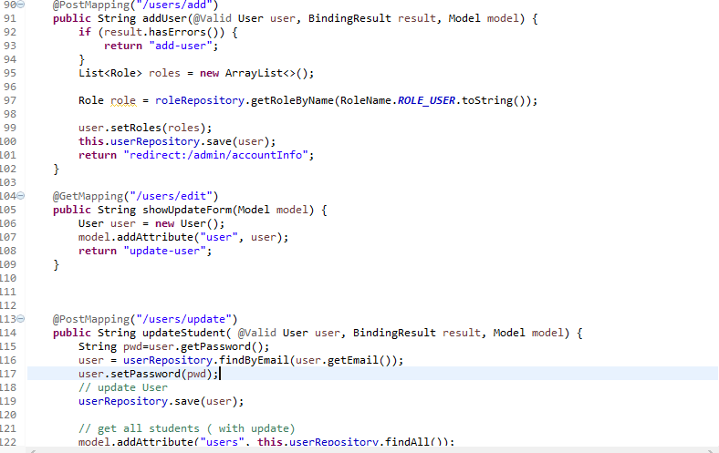

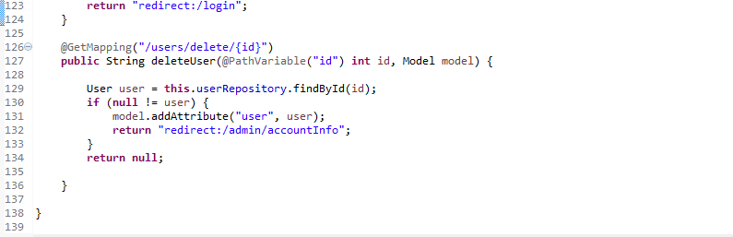

**🡪MainController.java**

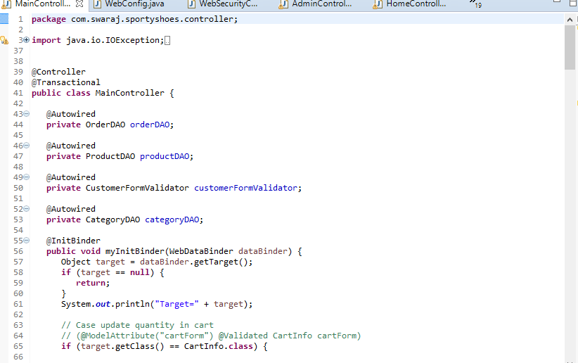

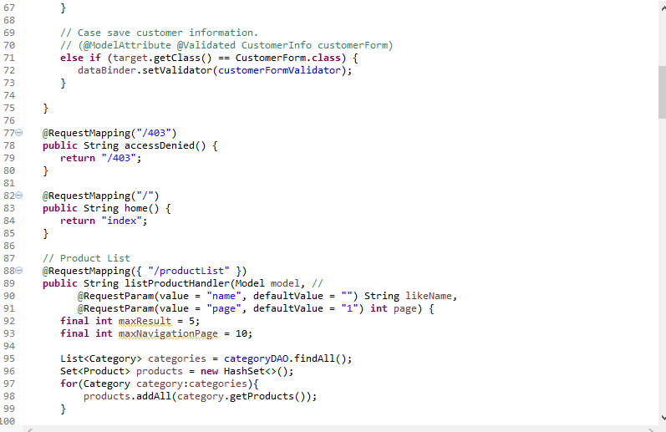

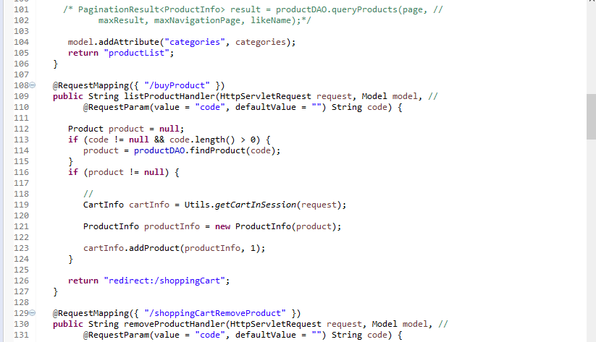

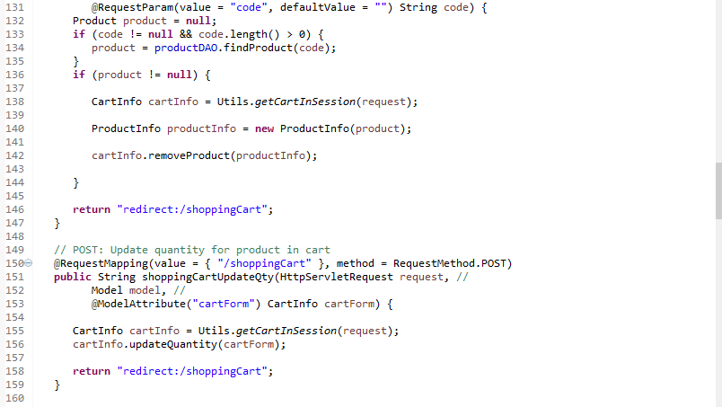

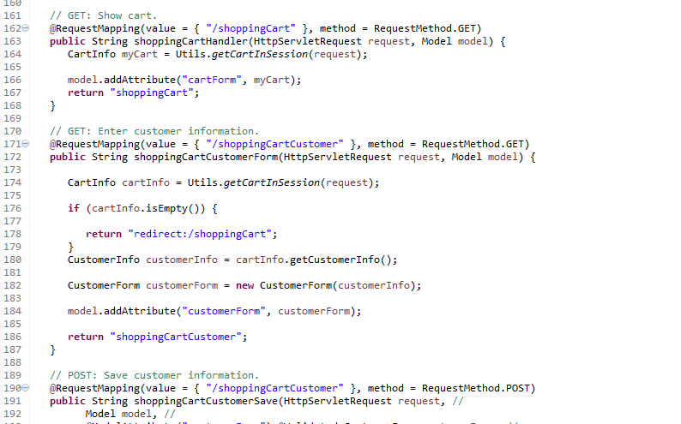

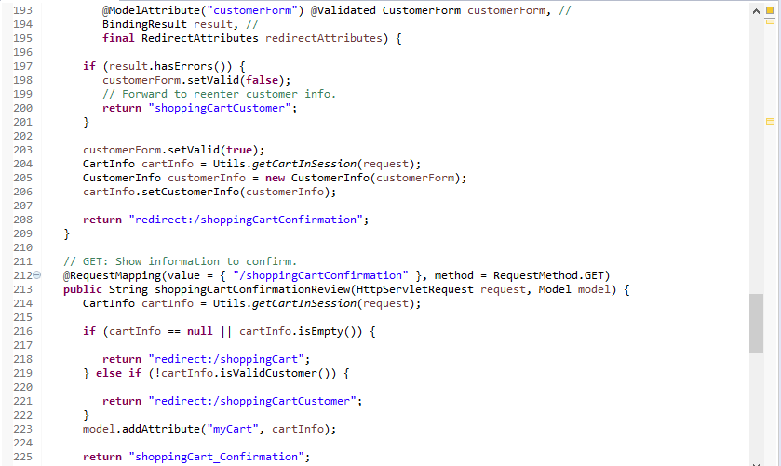

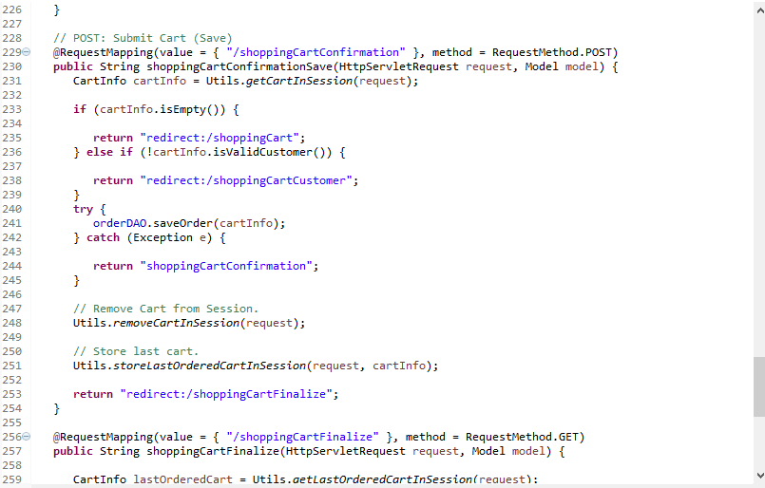

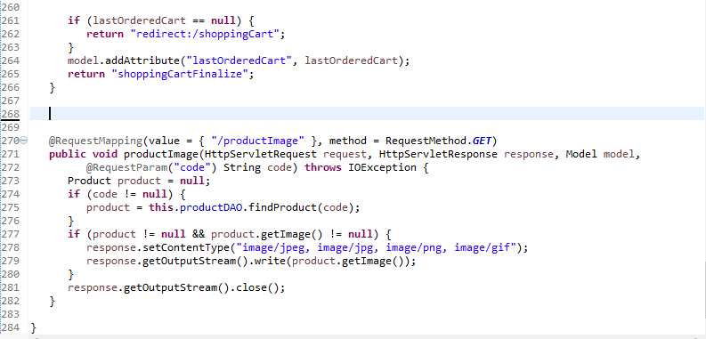

**4) com.swaraj.sportyshoes.entities**

**🡪Category.java**

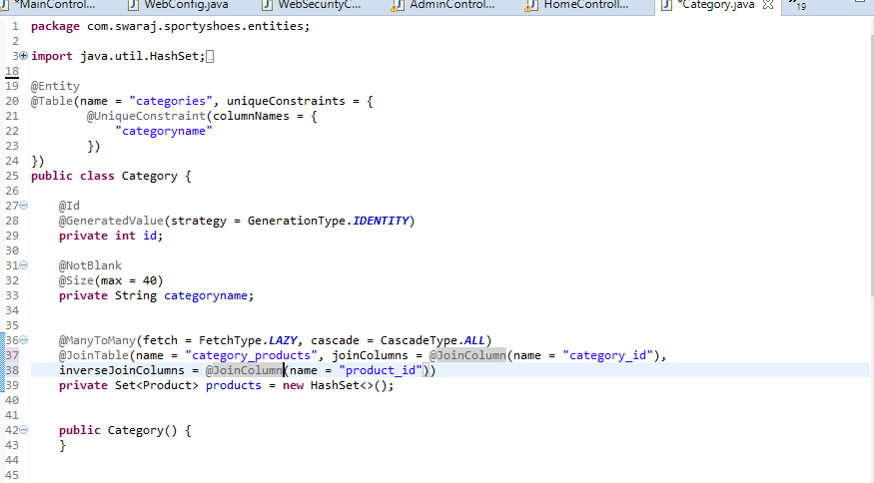

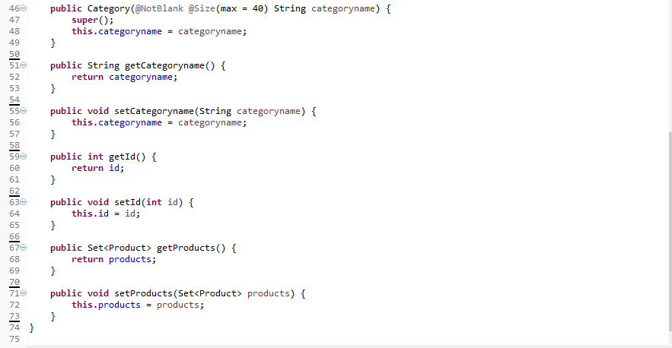

**🡪Order.java**

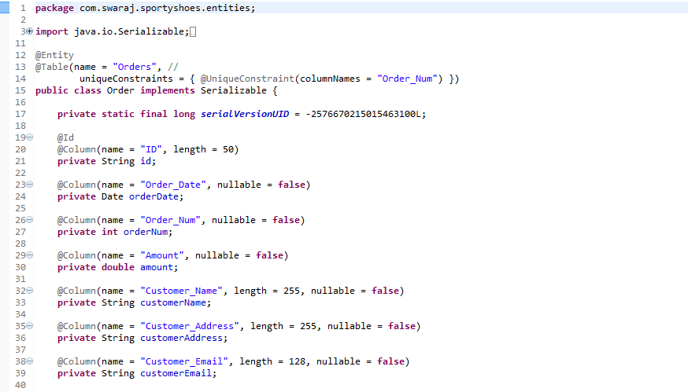

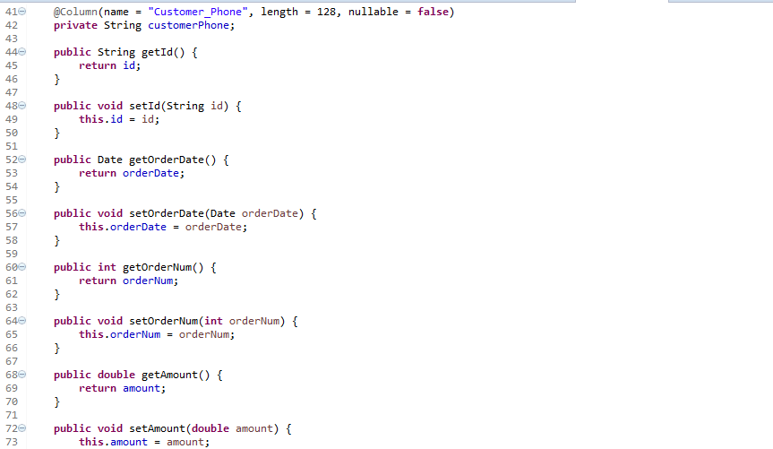

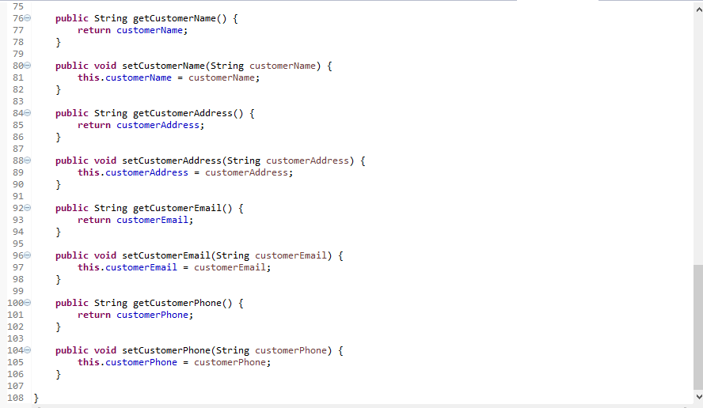

**🡪OrderDetail.java**

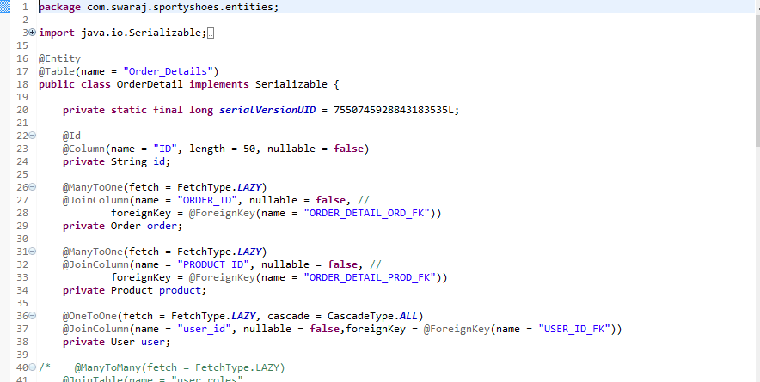

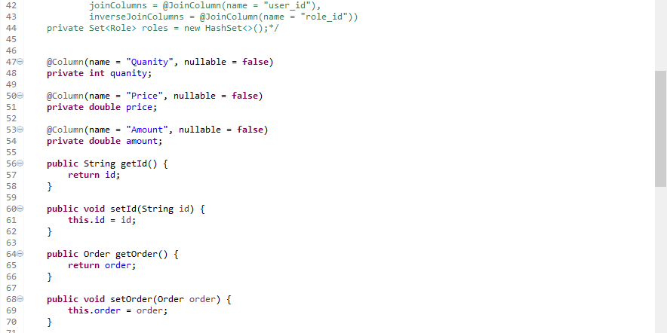

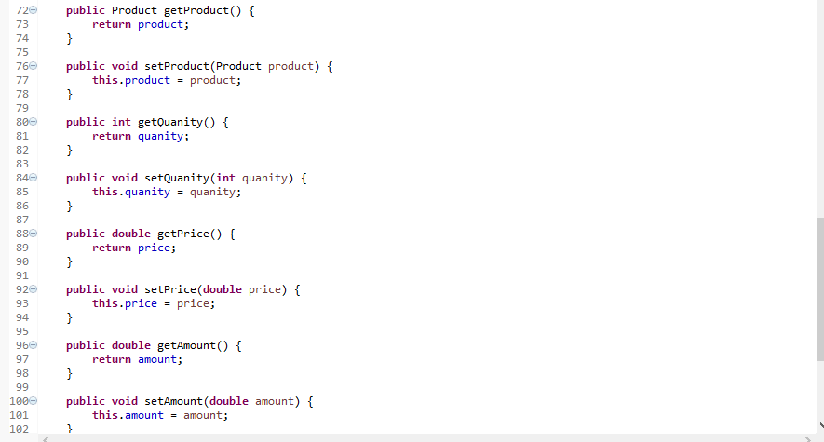

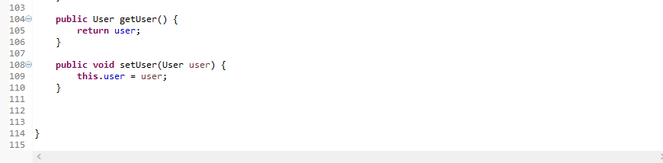

**🡪Product.java**

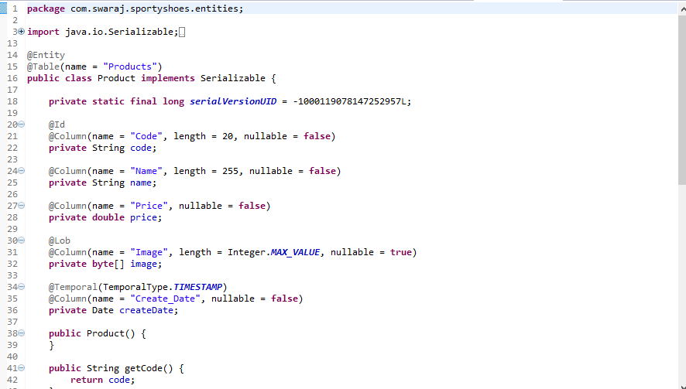

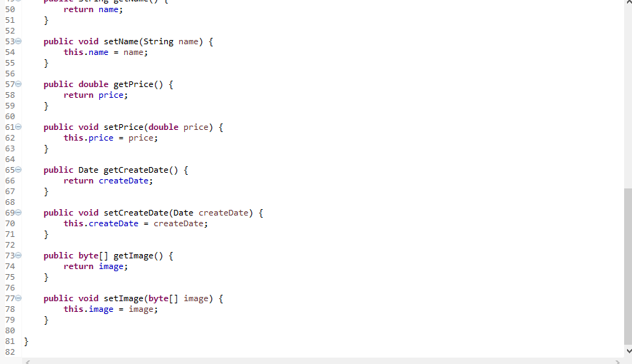

**🡪Role.java**

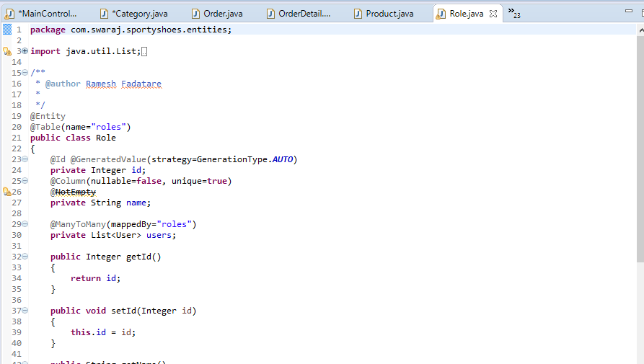

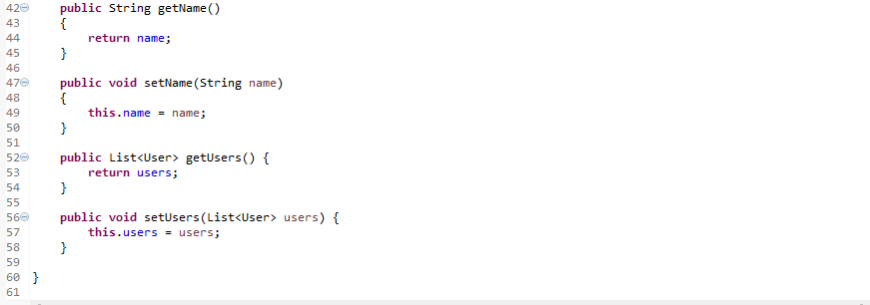

**🡪RoleName.java**

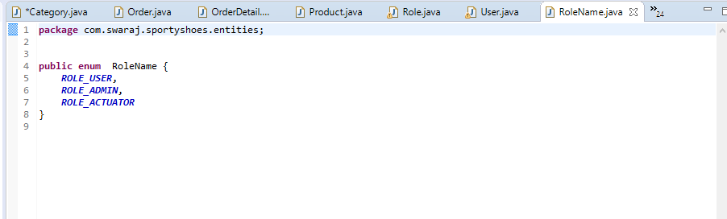

**🡪User.java**

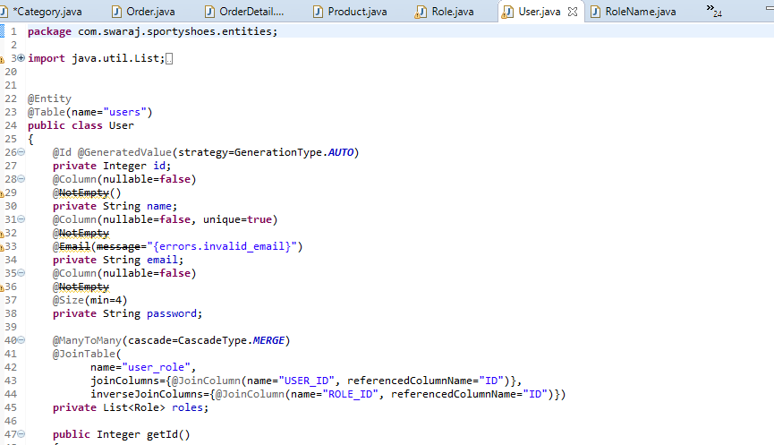

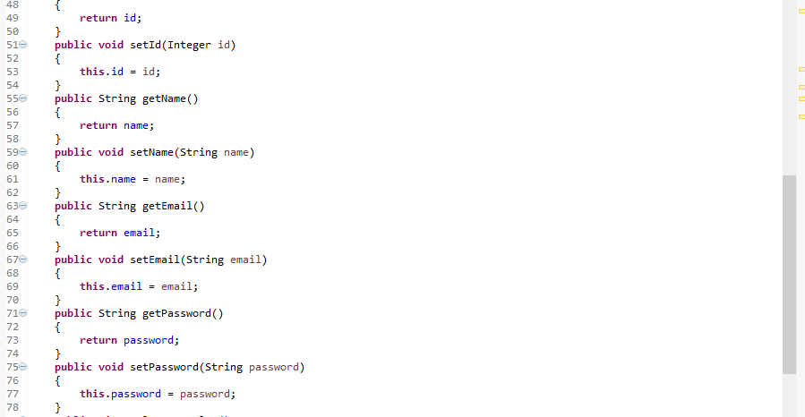

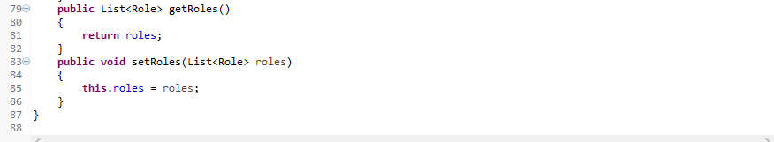

**5)com.swaraj.sportyshoes.form**

**🡪CategoryForm.java**

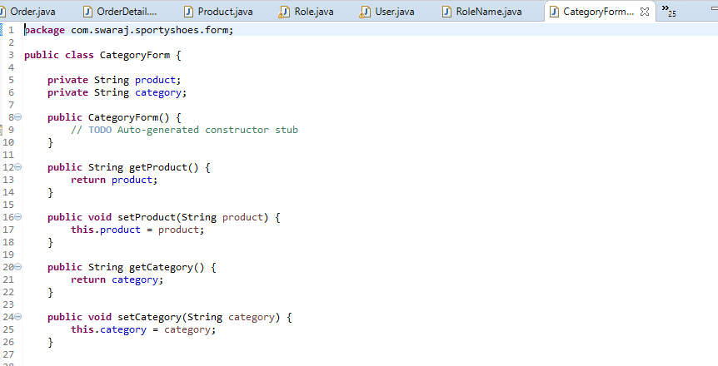

**🡪CustomerForm.java**

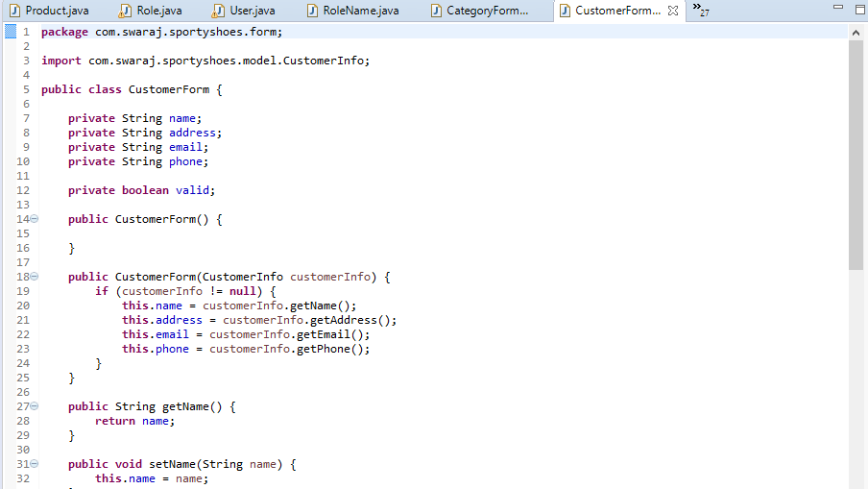

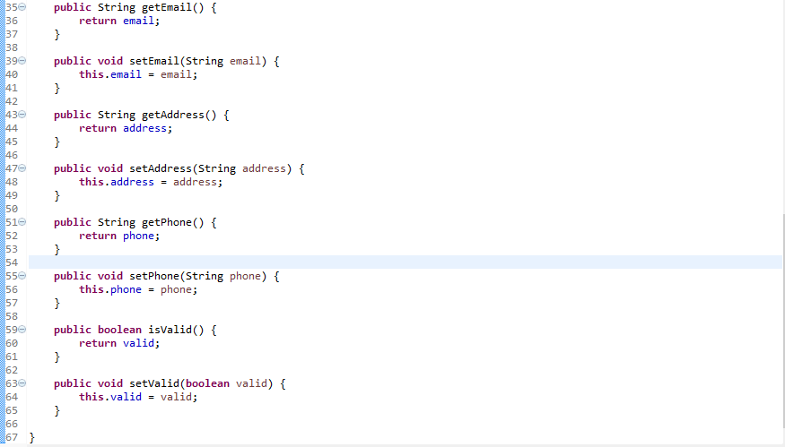

**🡪DateRange.java**

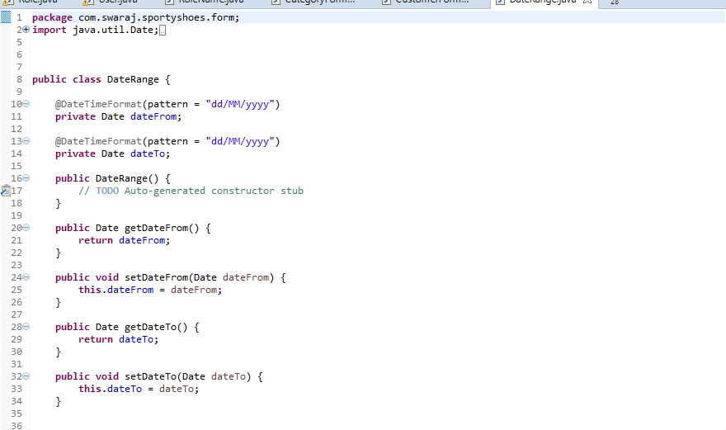

**🡪ProductForm.java**

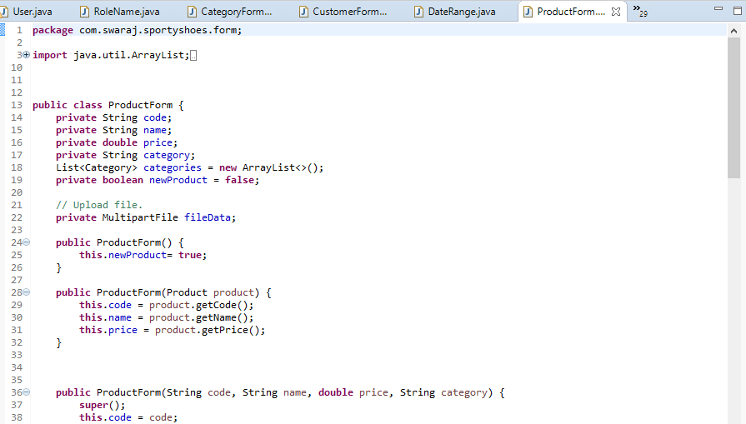

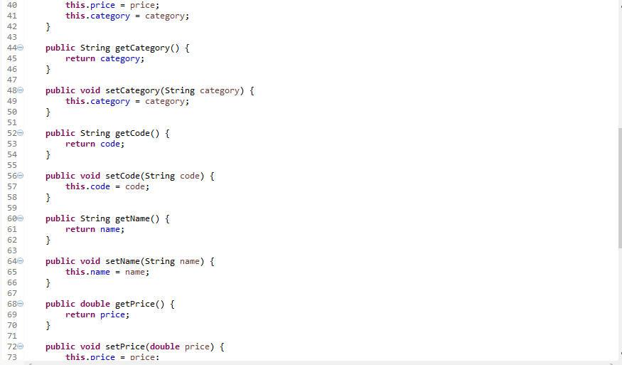

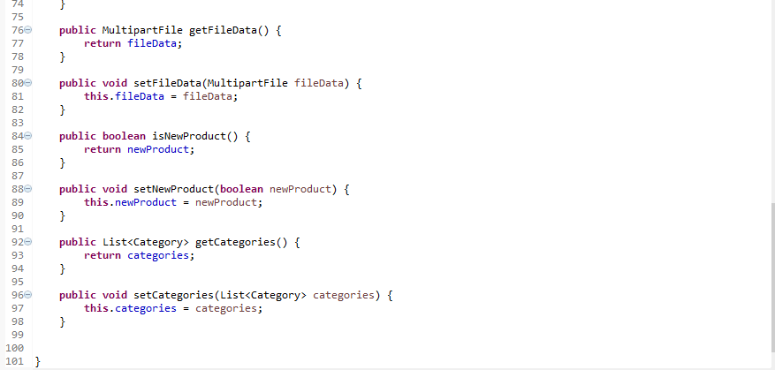

**6) com.swaraj.sportyshoes.model**

**🡪CartInfo.java**

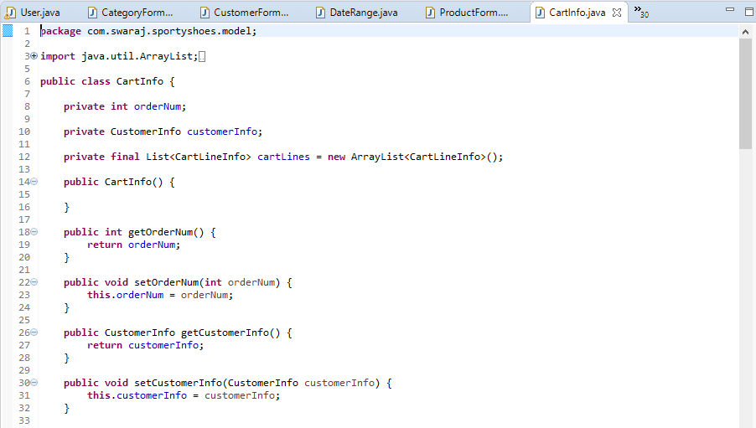

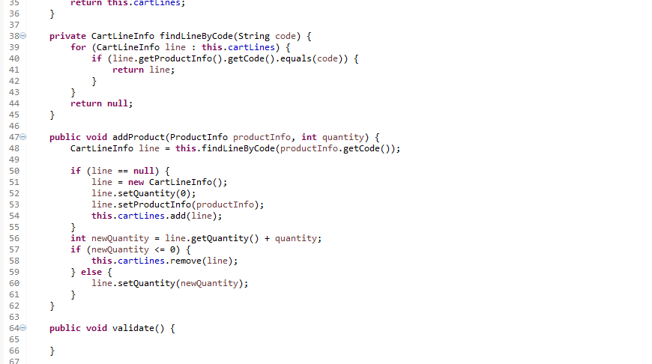

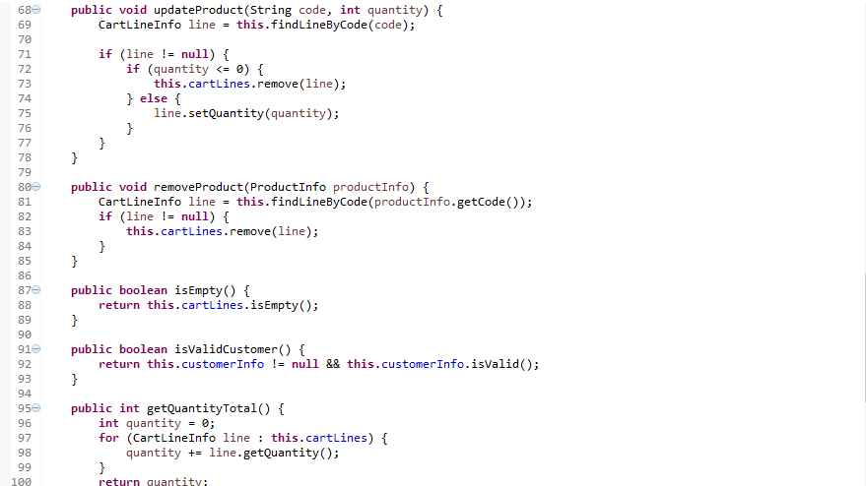

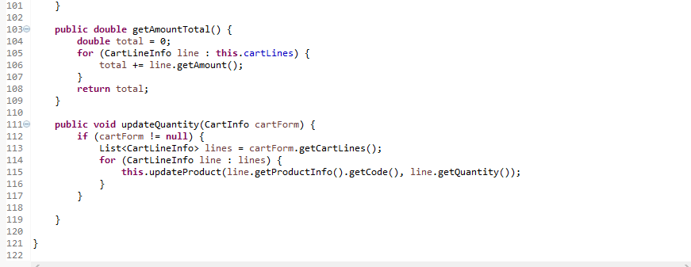

**🡪CartLineInfo.java**

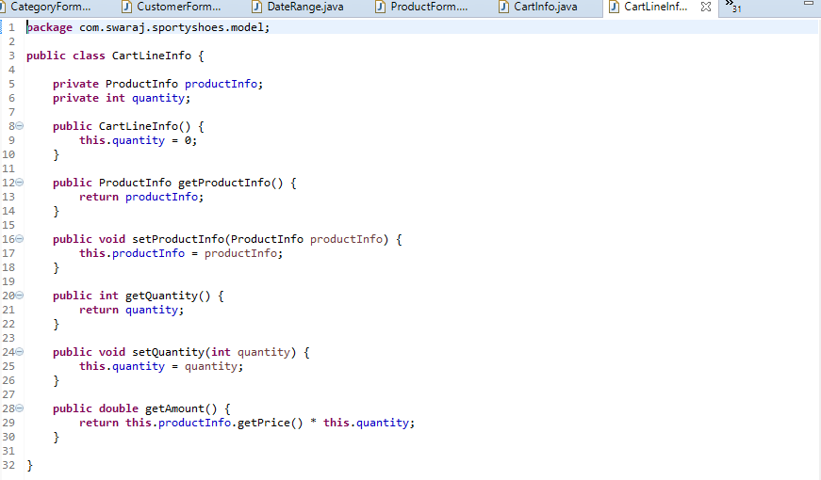

**🡪CustomerInfo.java**

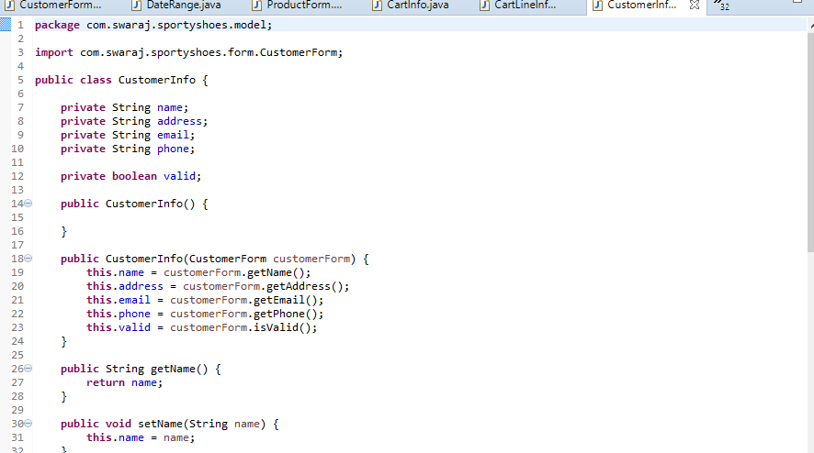

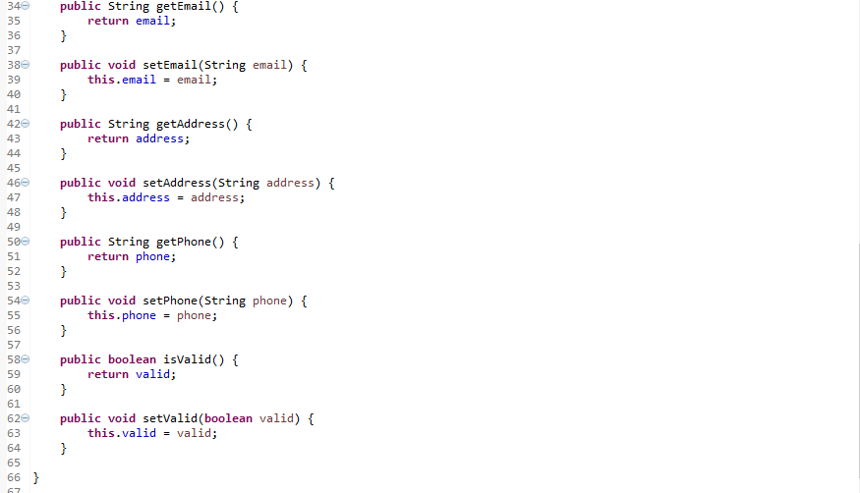

**🡪OrderDetailInfo.java**

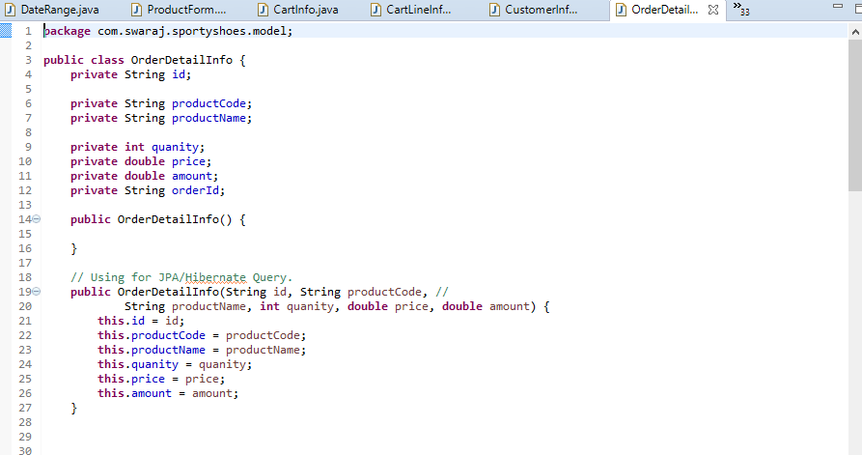

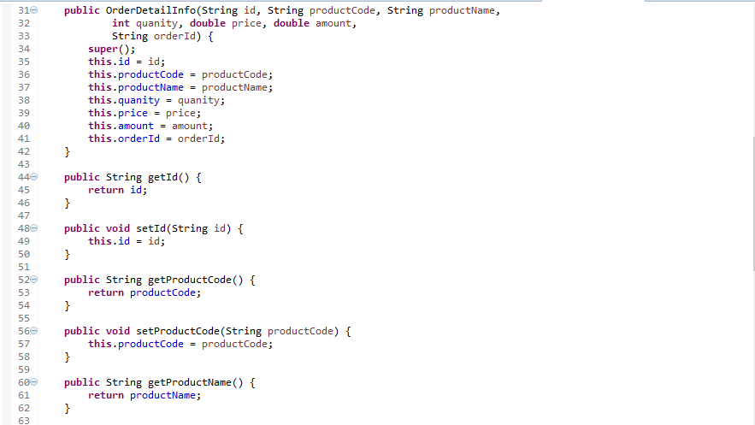

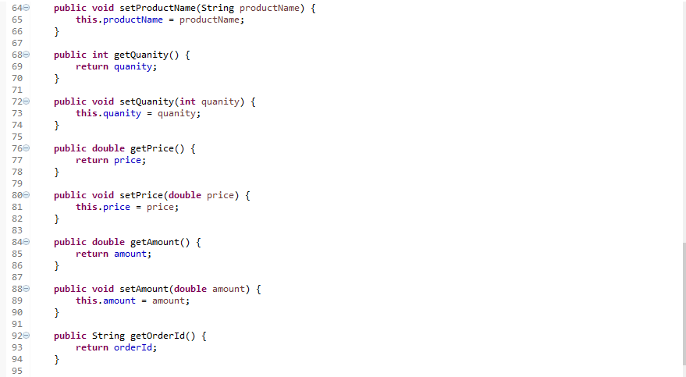

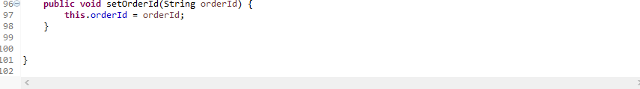

**🡪OrderInfo.java**

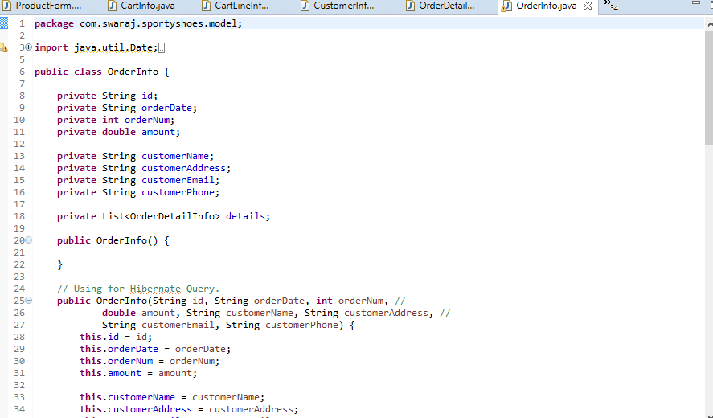

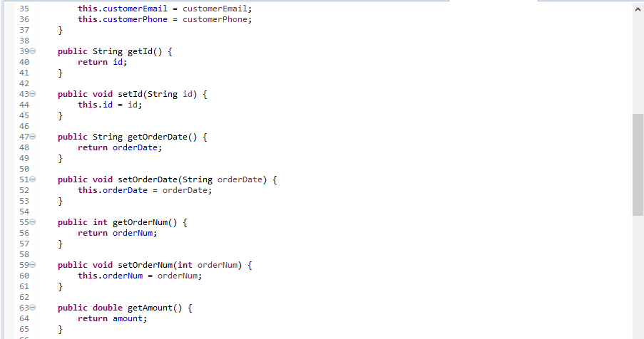

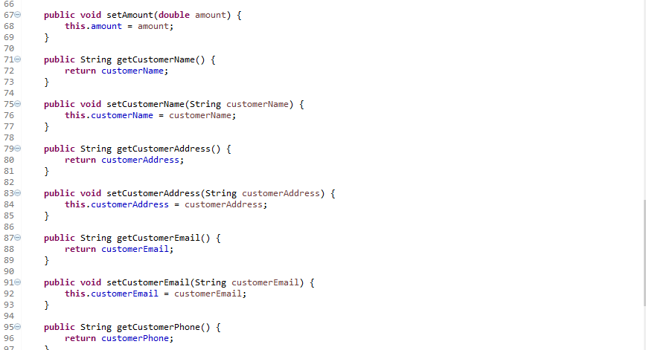

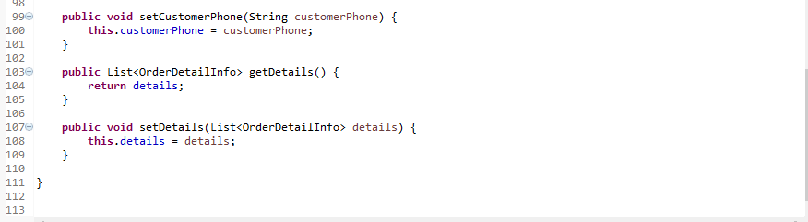

**🡪ProductInfo.java**

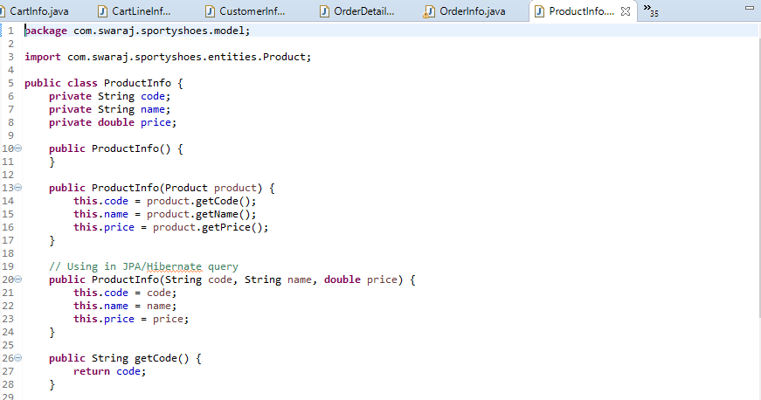

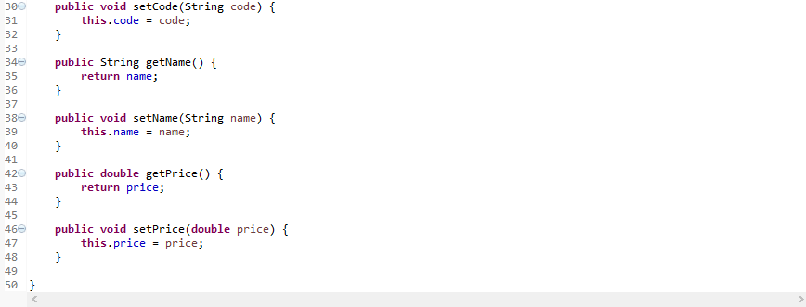

**7) com.swaraj.sportyshoes.pagination**

**🡪PaginationResult.java**

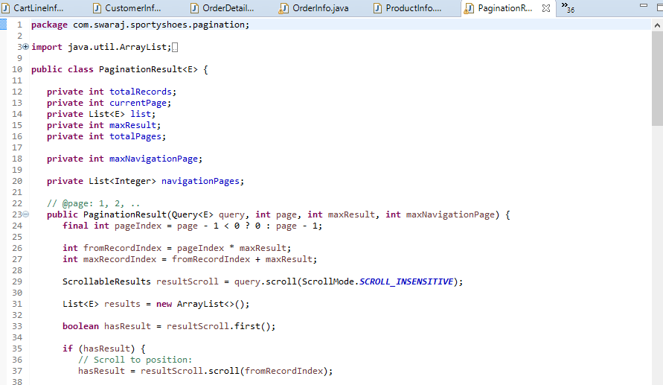

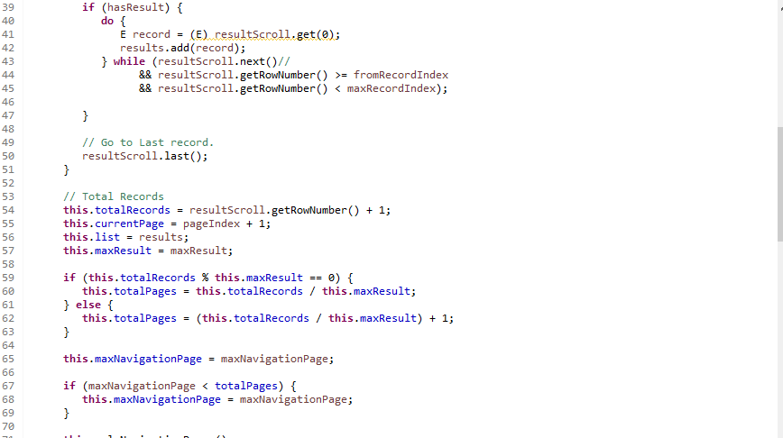

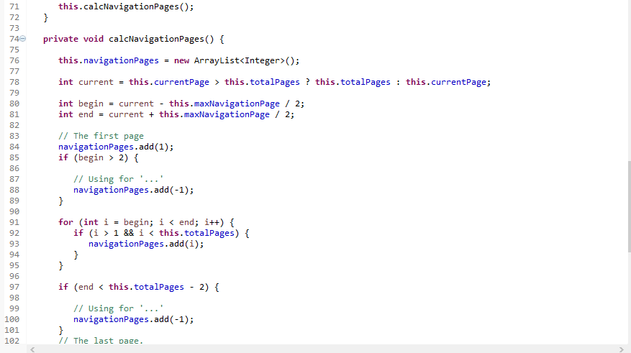

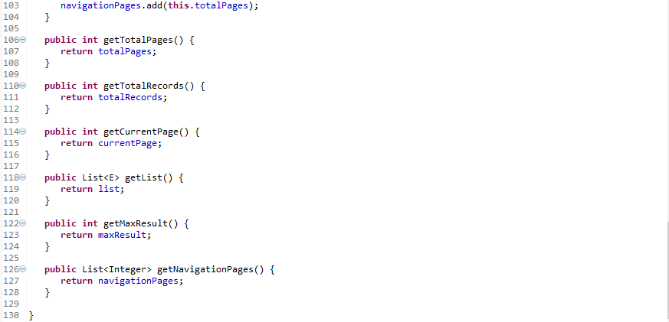

**8) com.swaraj.sportyshoes.repositories**

**🡪CatogoryDAO.java**

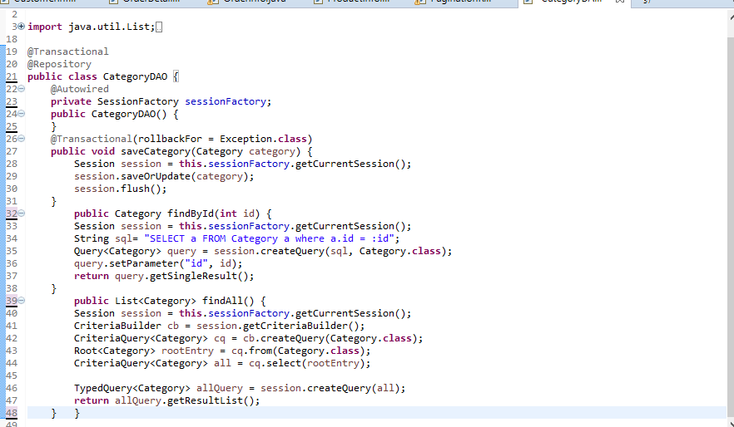

**🡪OrderDAO.java**

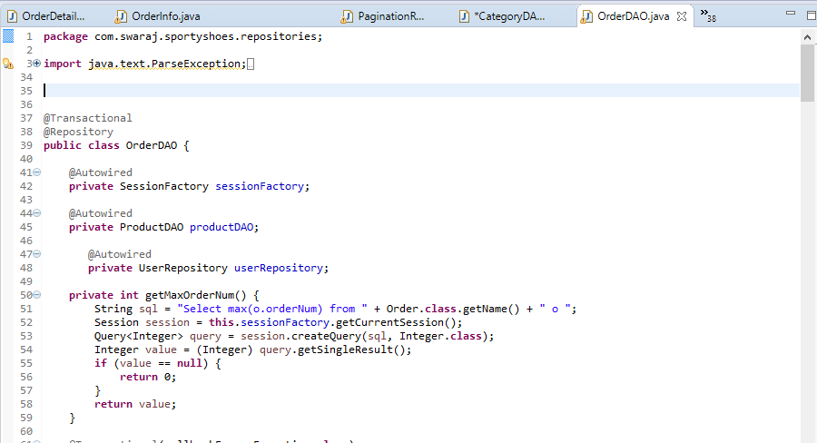

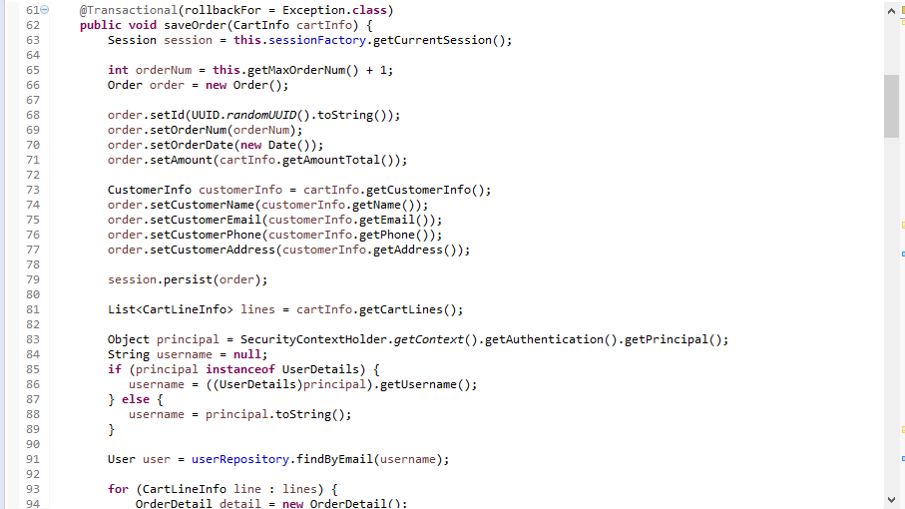

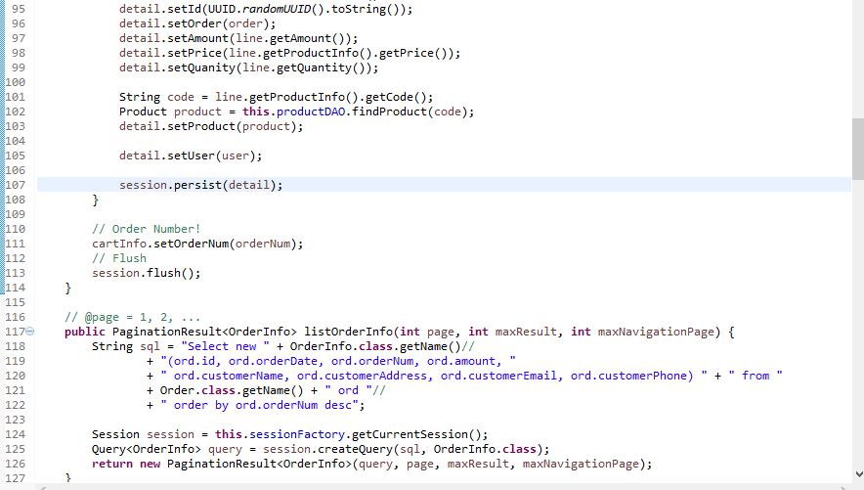

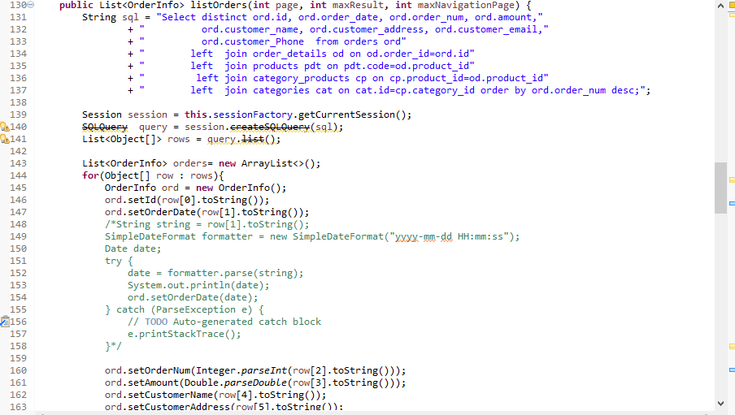

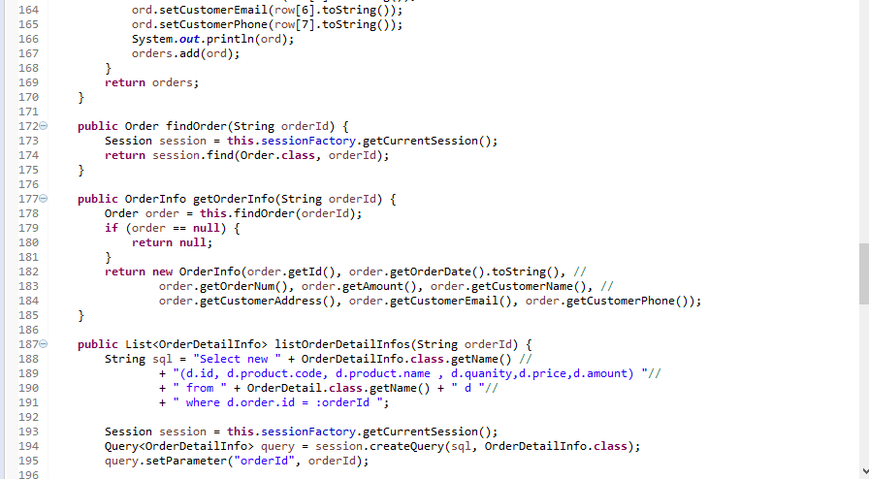

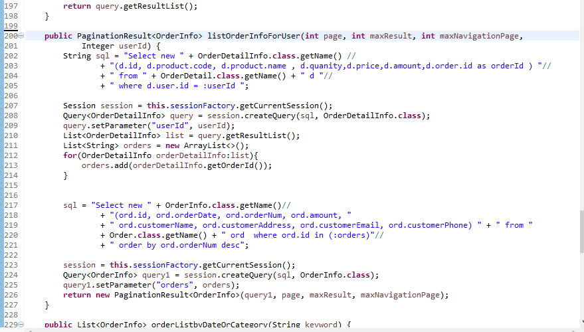

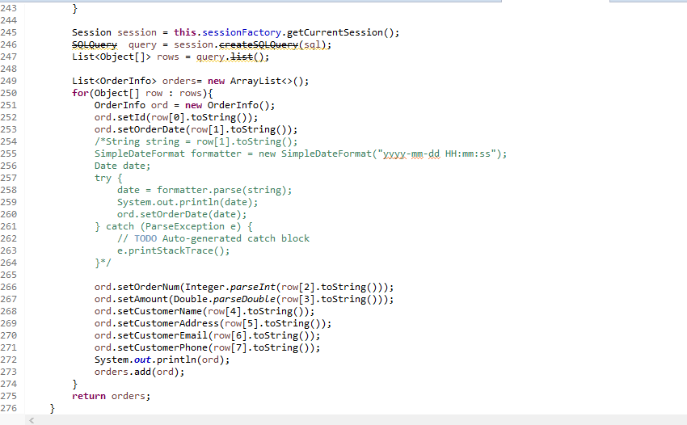

**🡪ProductDAO.java**

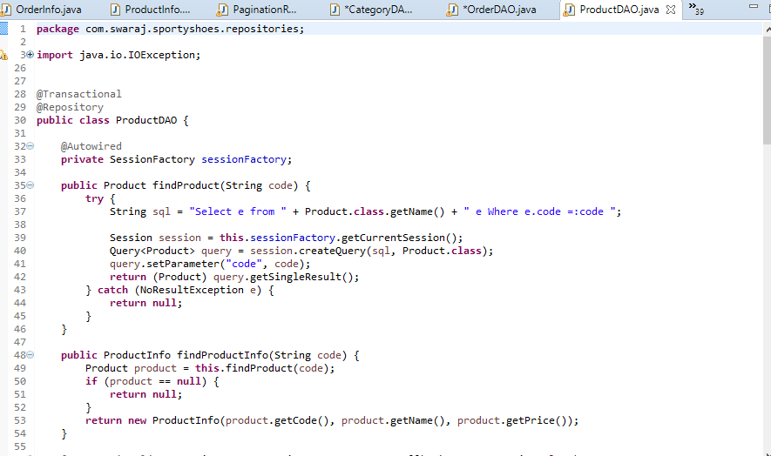

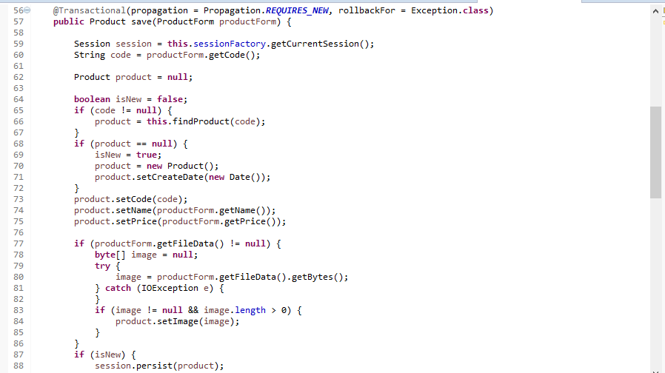

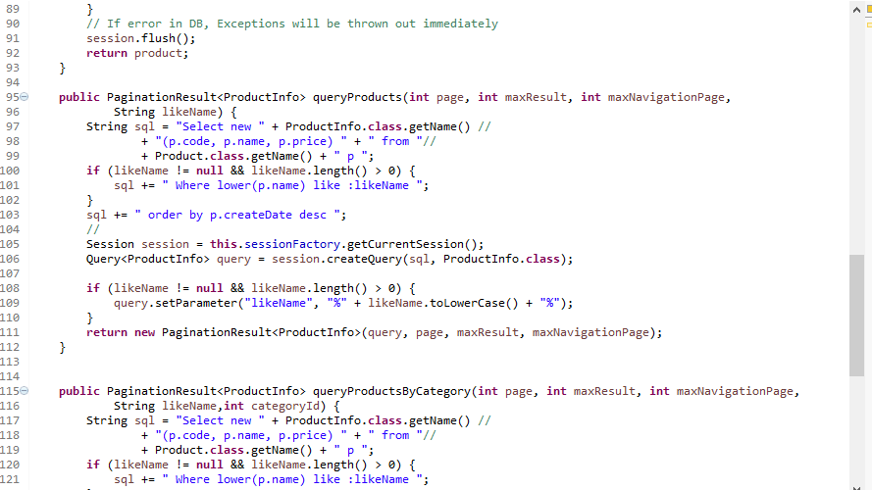

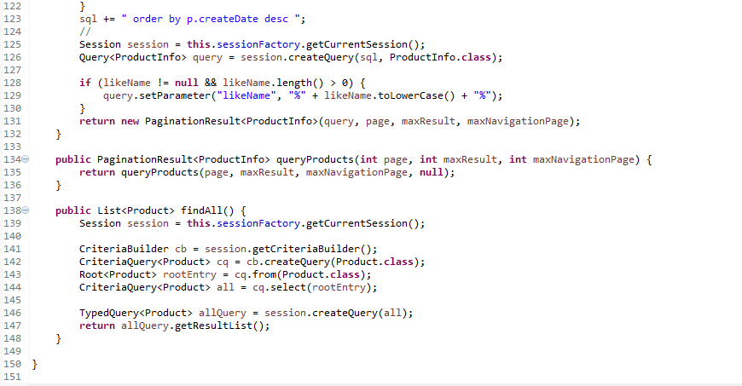

**🡪RoleRepository.java**

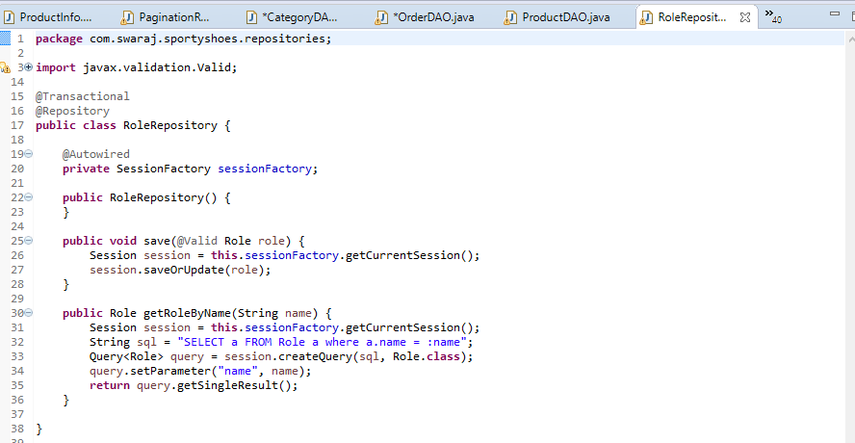

**🡪UserRepository.java**

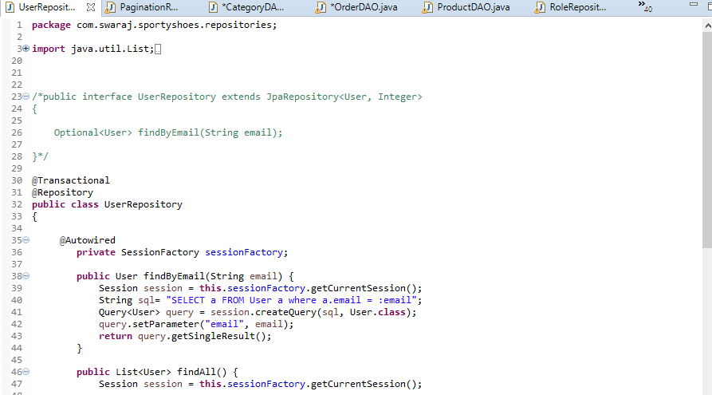

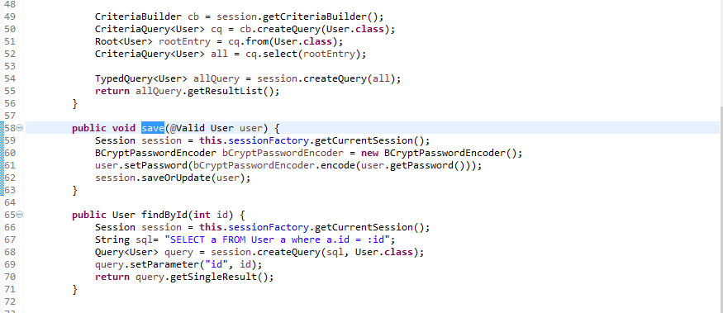

**9) com.swaraj.sportyshoes.security**

**🡪AuthenticatedUser.java**

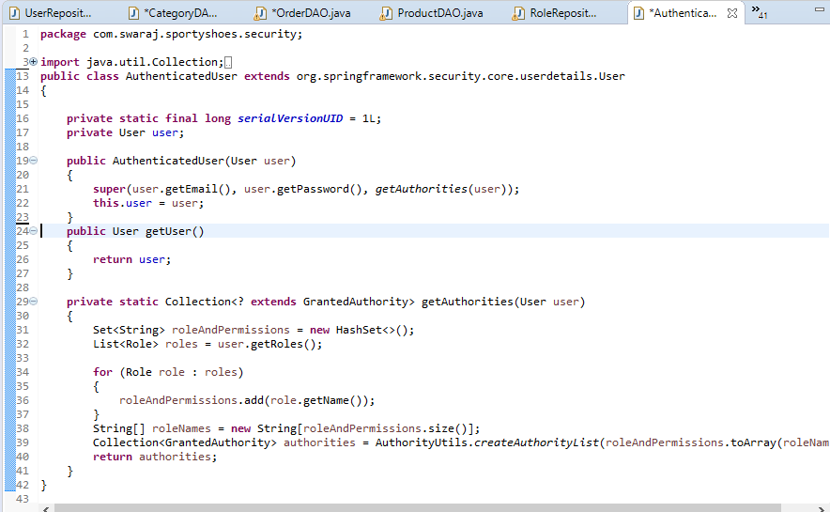

**🡪CustomUserDetailsService.java**

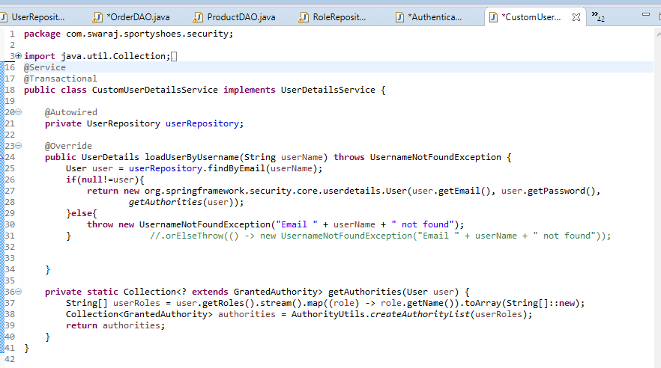

**10) com.swaraj.sportyshoes.utils**

**🡪Utils.java**

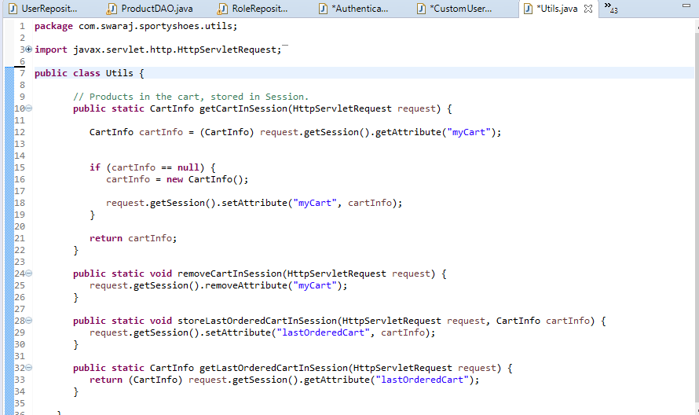

**11) com.swaraj.sportyshoes.validotor**

**🡪CustomerFormValidator.java**

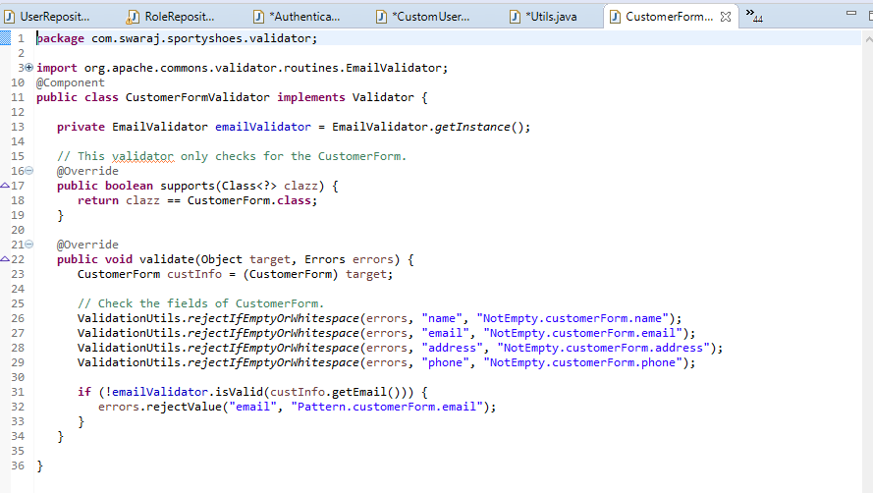

**🡪ProductFormValidator.java**

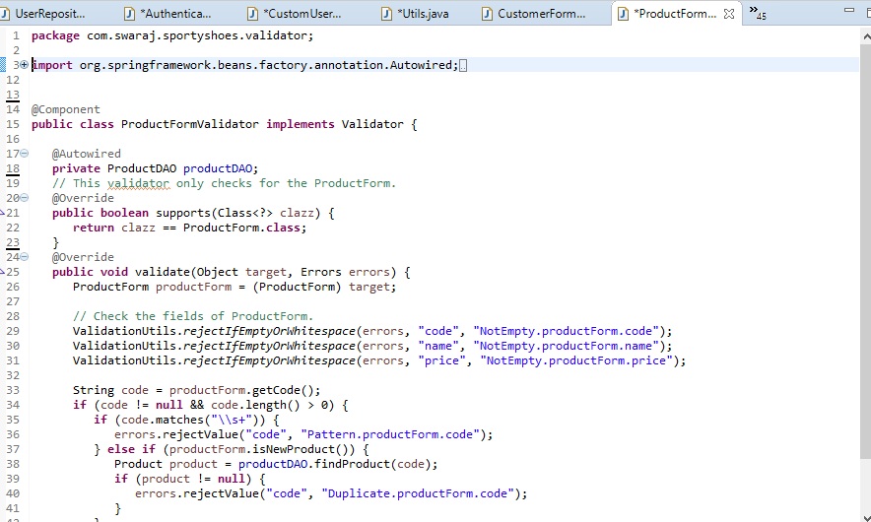

**Main Folder 🡪 To create a new Project 🡪 package🡪 EcommerceSportyShoes🡪**

**Src/main/resources**

**1)error**

**🡪403.html**

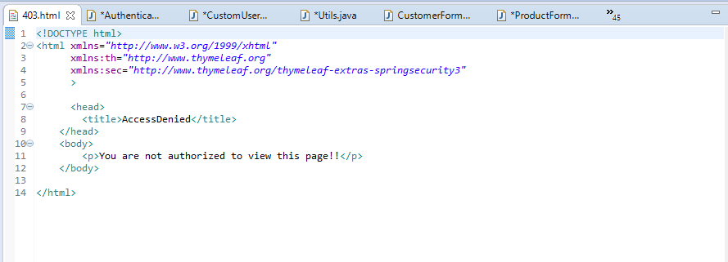

**🡪daterangepicker.css**

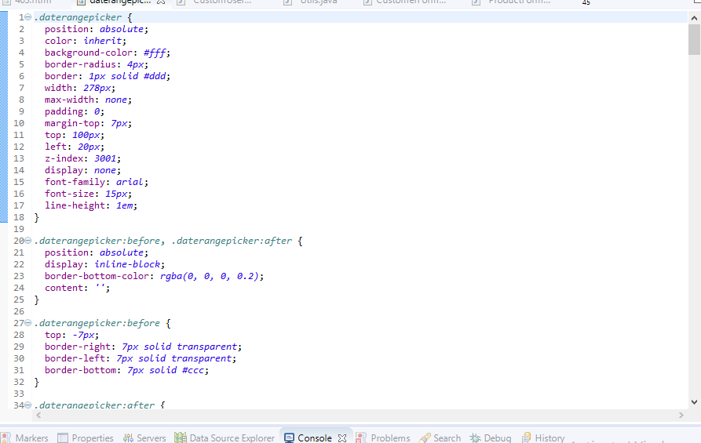

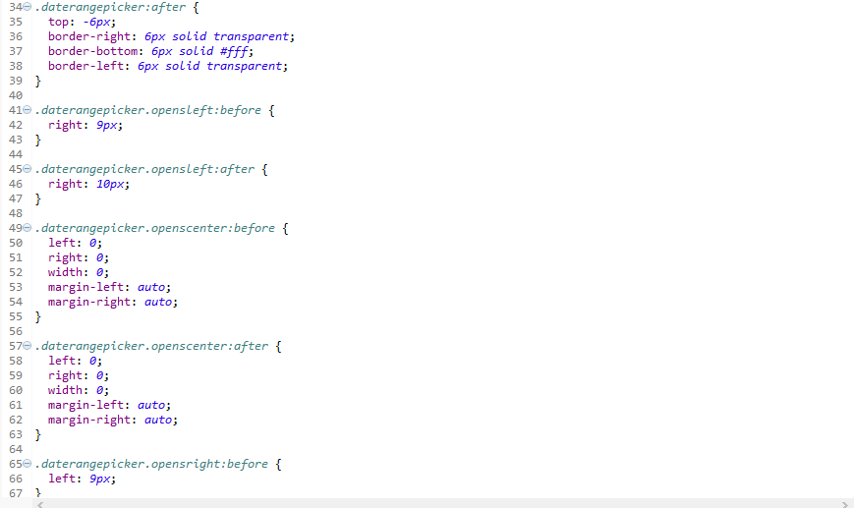

**🡪Style.css**

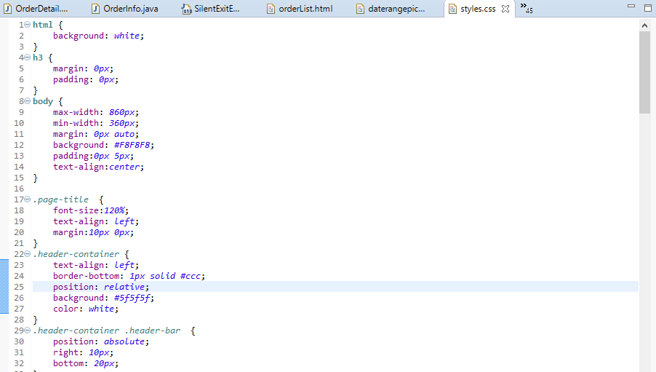

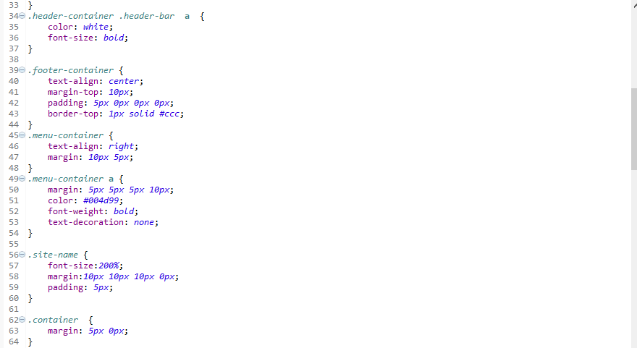

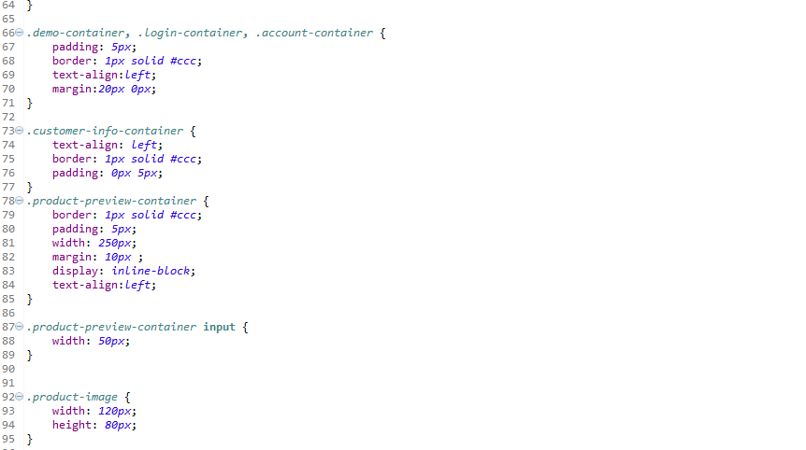

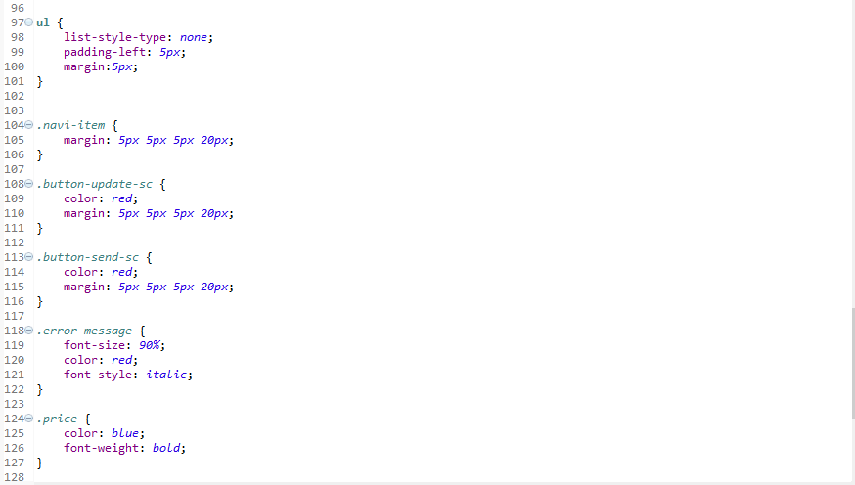

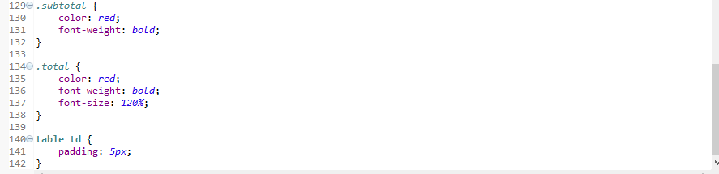

**2)templates**

**🡪footer.html**

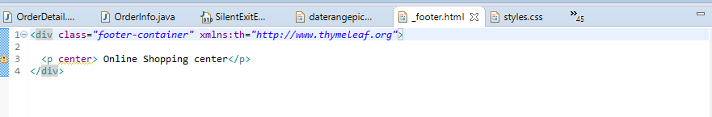

**🡪header.html**

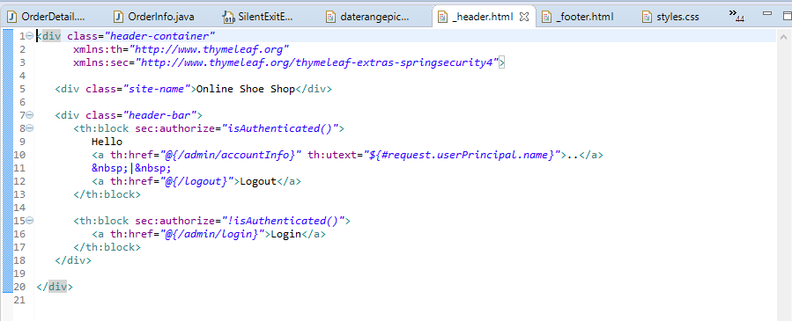

**🡪menu.html**

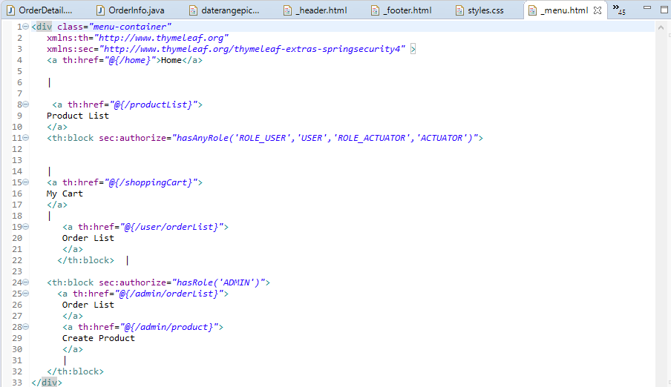

**🡪403.html**

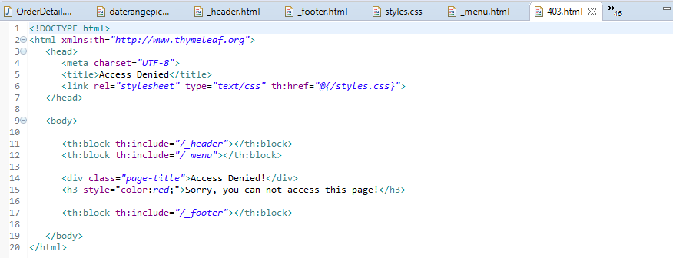

**🡪accountinfo.html**

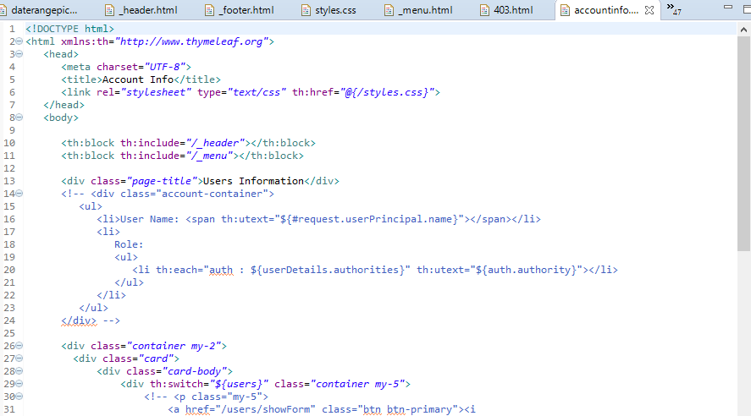

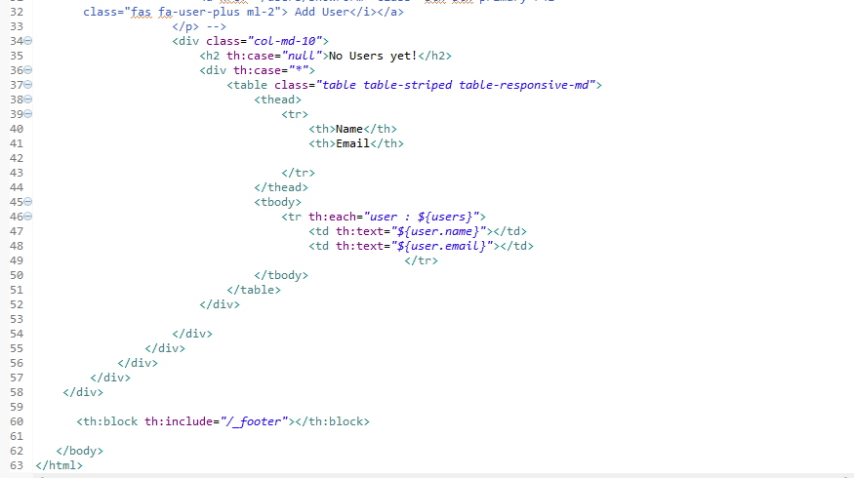

**🡪add-user.html**

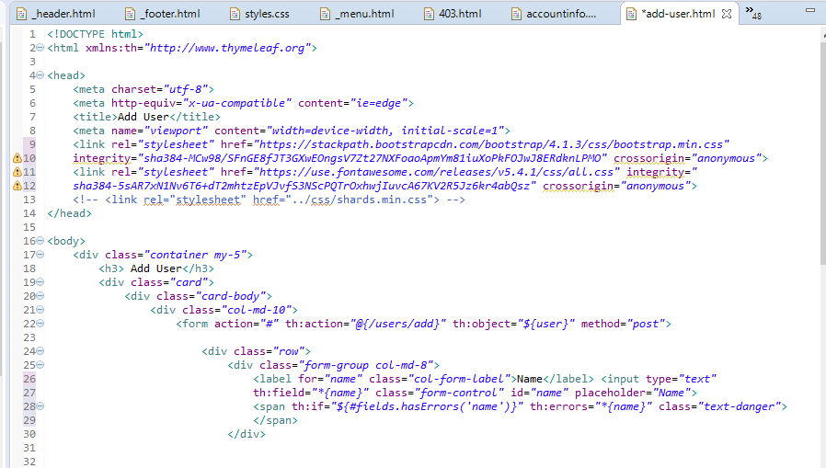

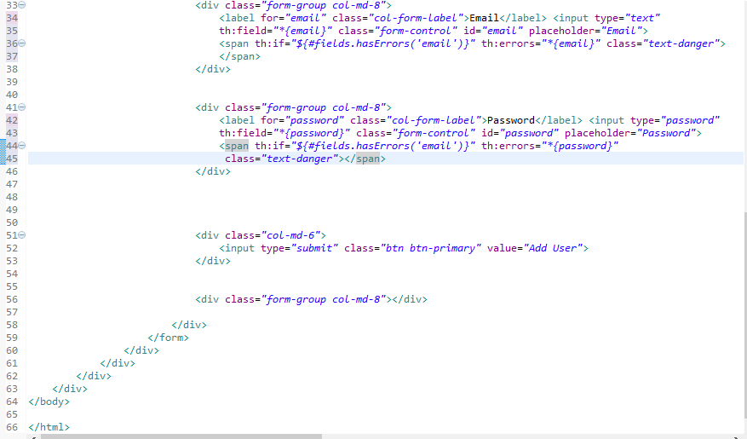

**🡪adminhome.html**

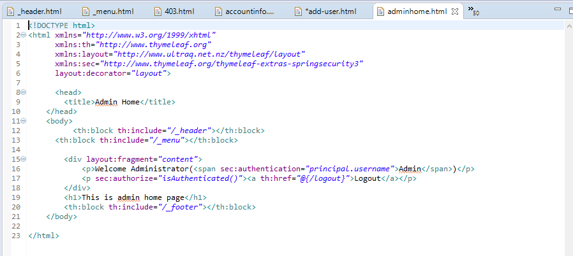

**🡪category-product.html**

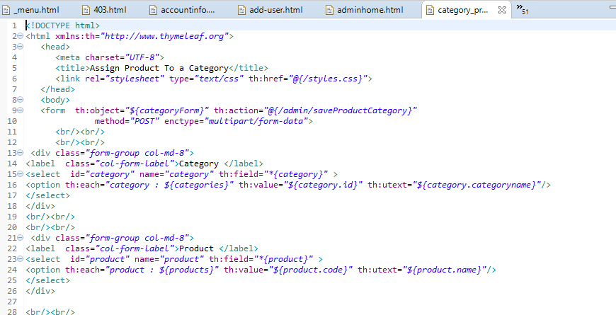

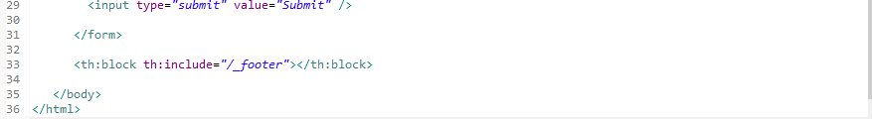

**🡪index.html**

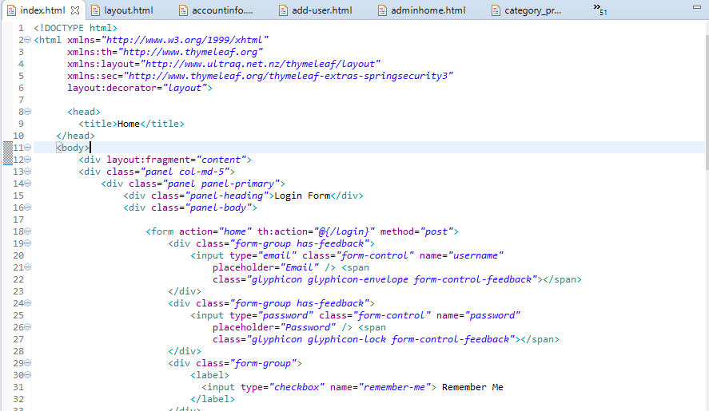

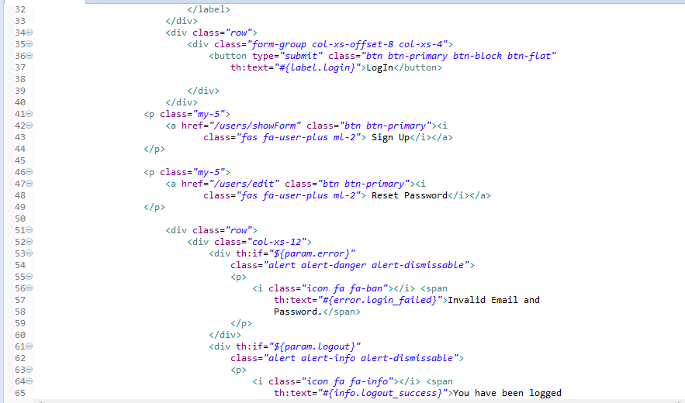

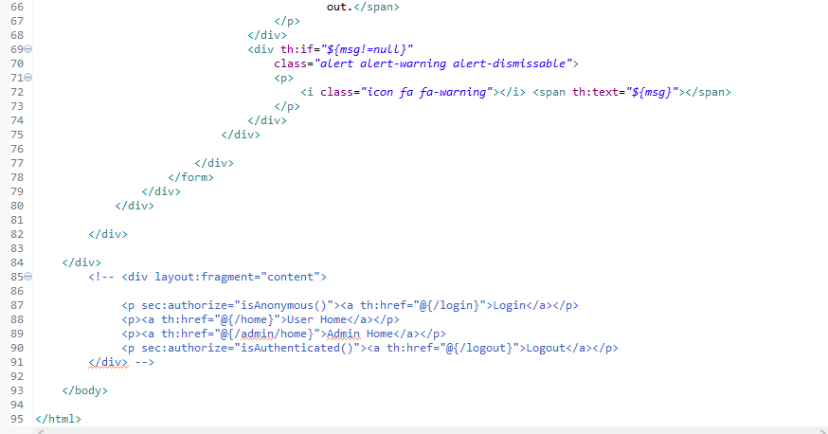

**🡪layout.html**

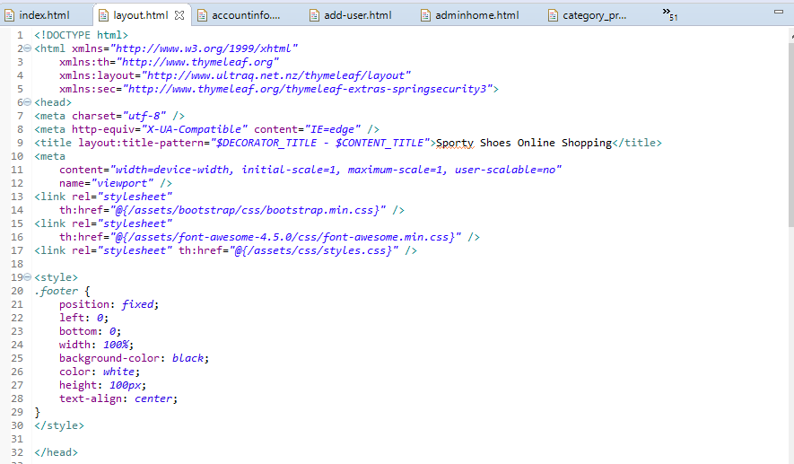

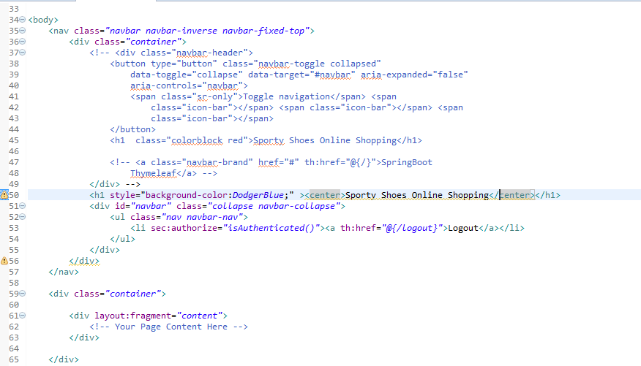

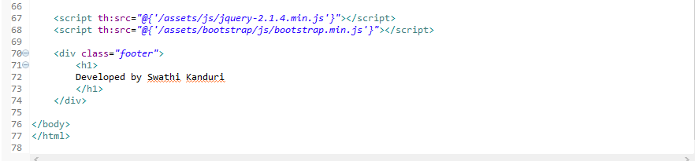

**🡪login.html**

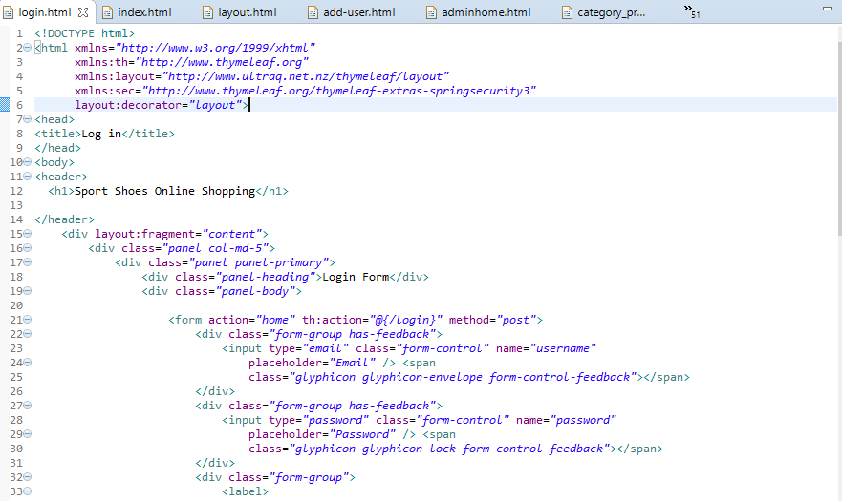

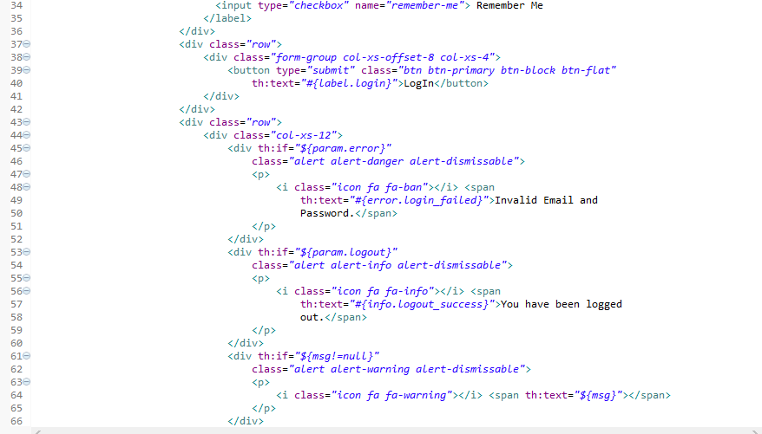

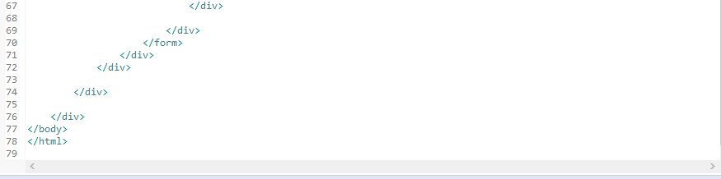

**🡪order.html**

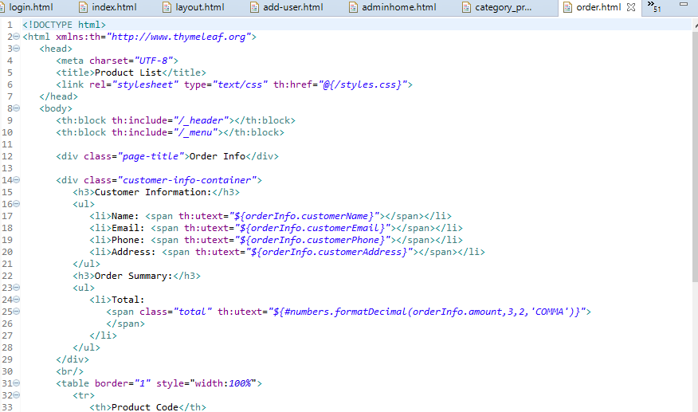

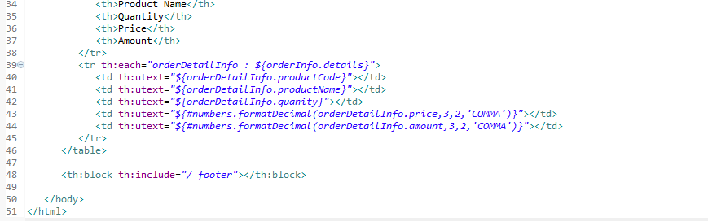

**🡪orderlist.html**

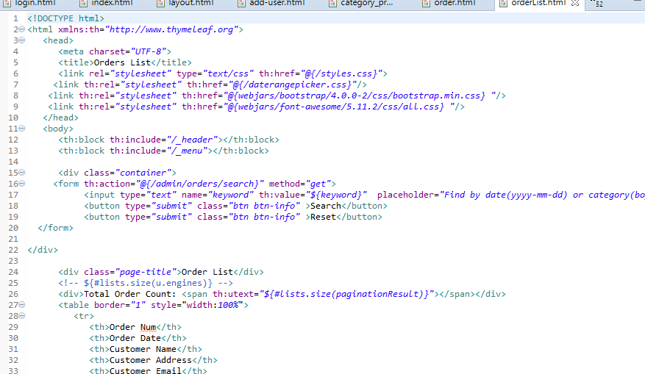

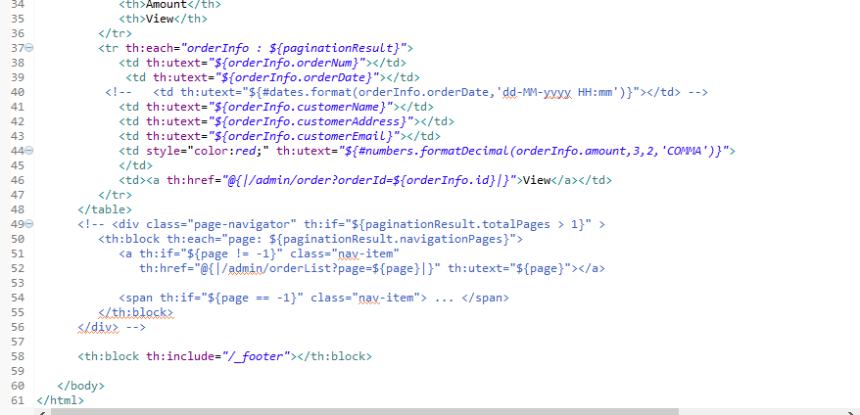

**🡪product.html**

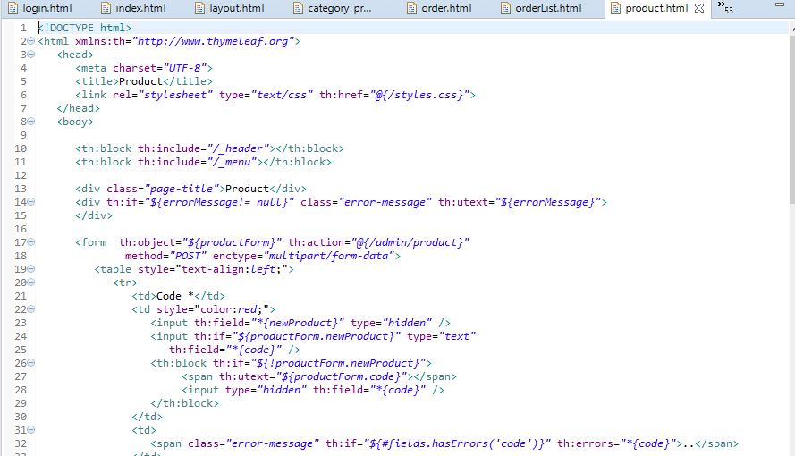

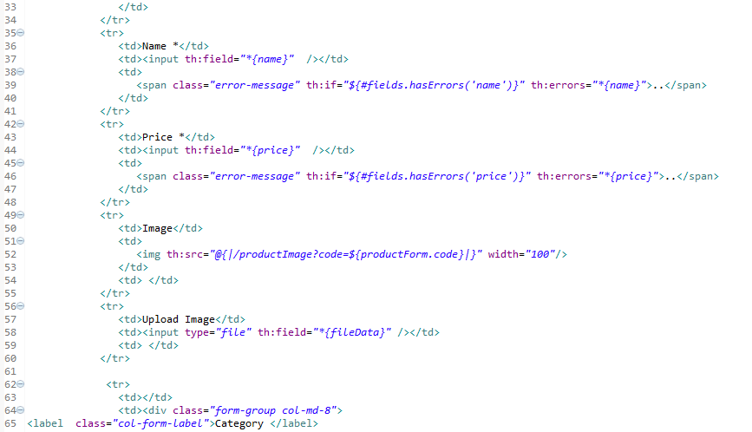

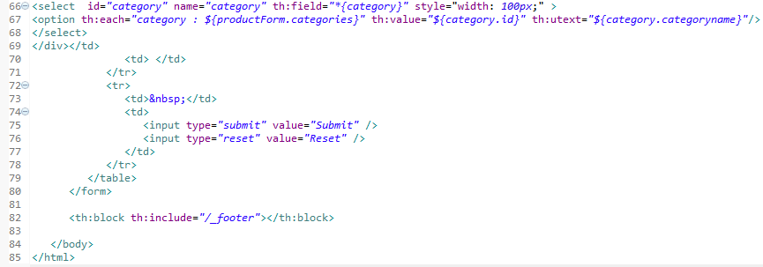

**🡪 productlist.html**

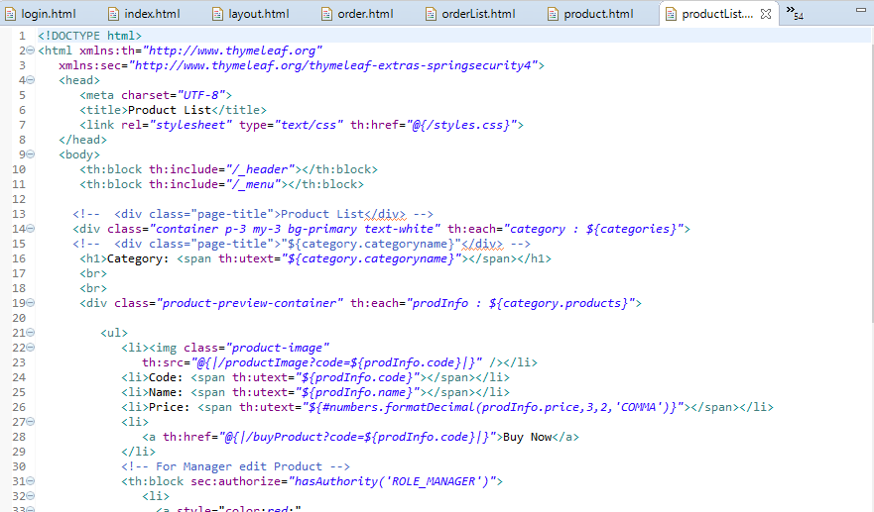

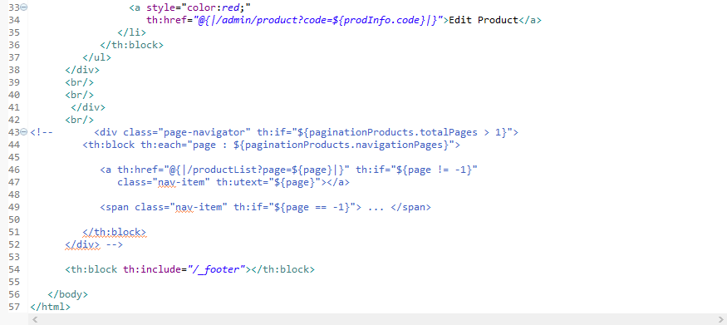

**🡪shoppingCartConfirmation.html**

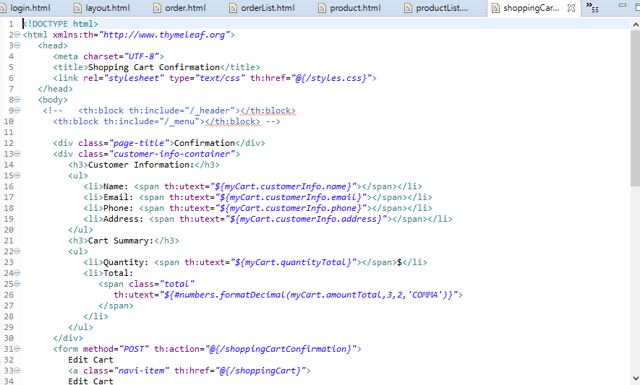

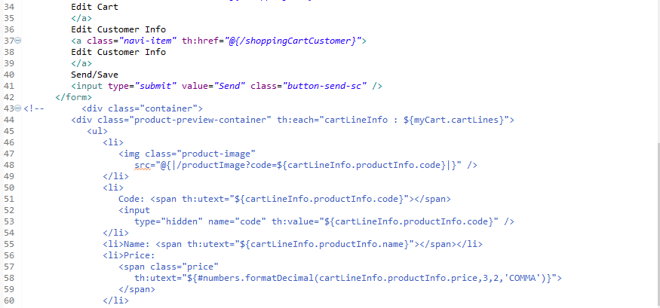

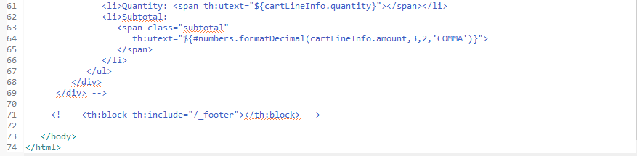

**🡪ShoppingCart.html**

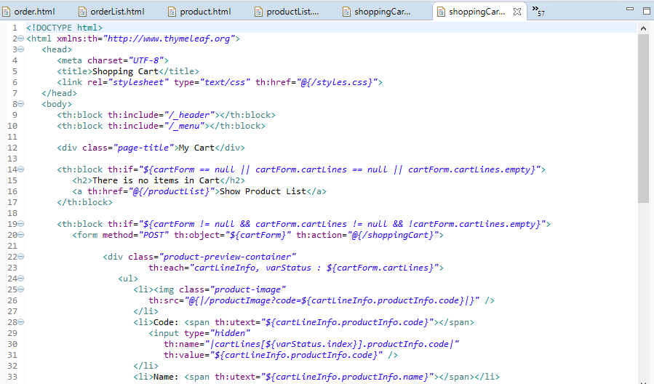

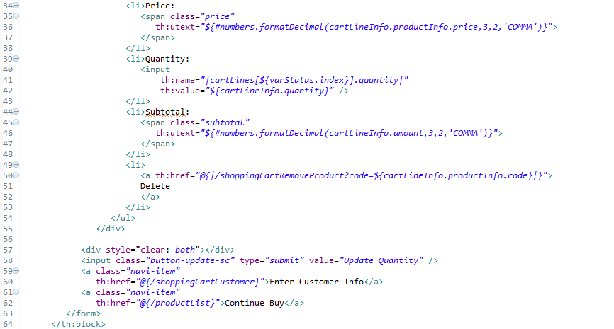

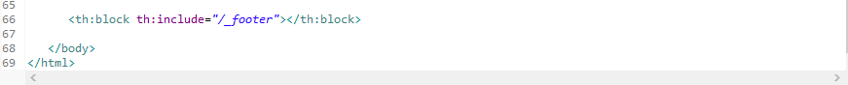

**🡪shoppingcartCustomer.html**

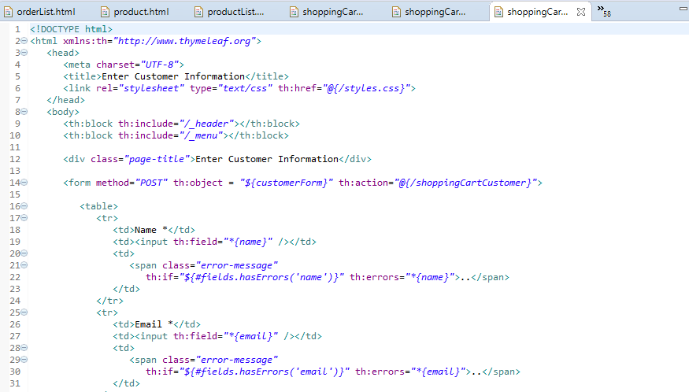

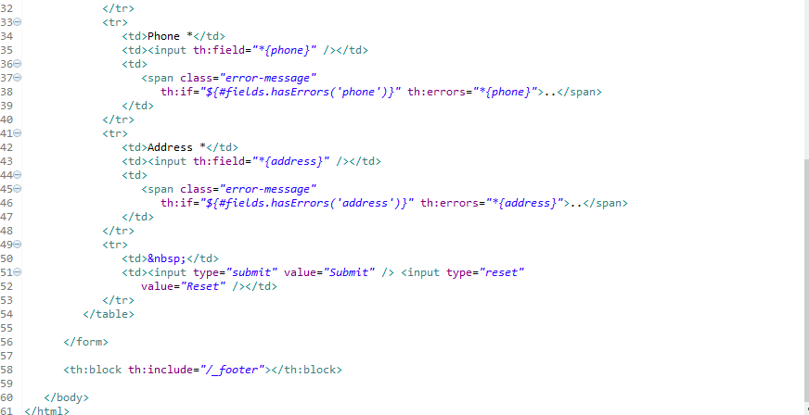

**🡪shoppingcartFinalize.html**

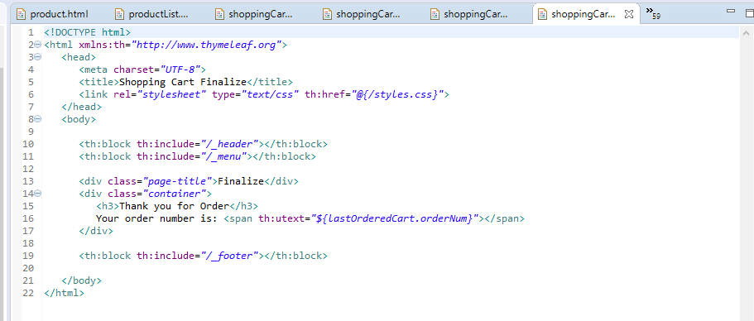

**🡪updateuser.html**

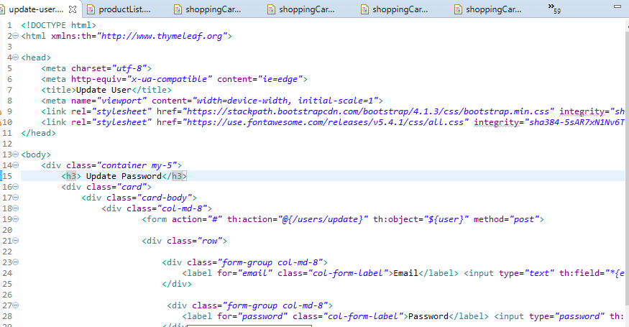

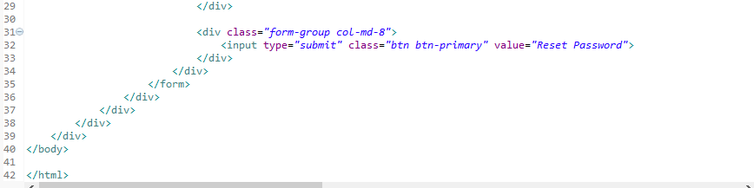

**🡪userhome.html**

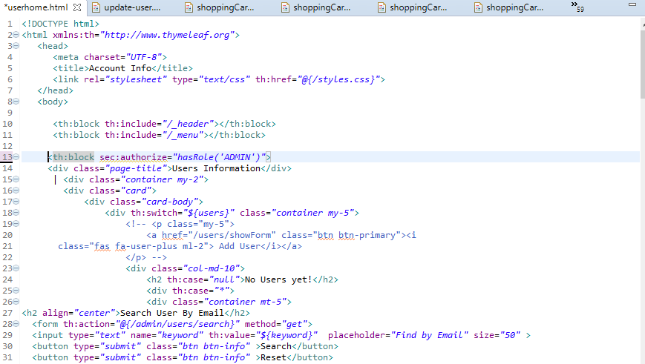

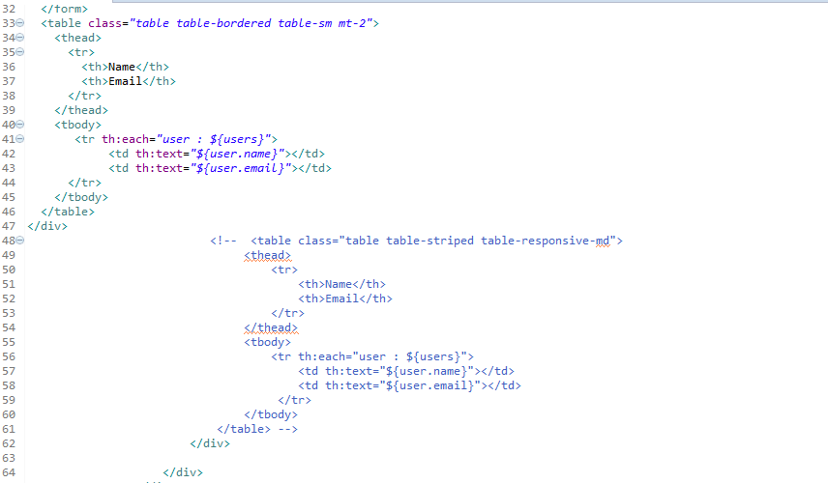

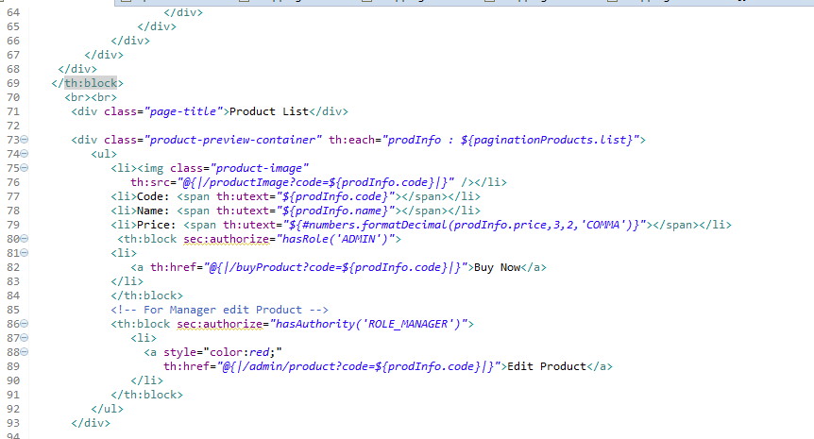

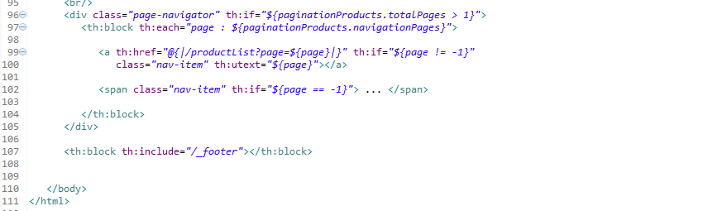

**🡪application.properties**

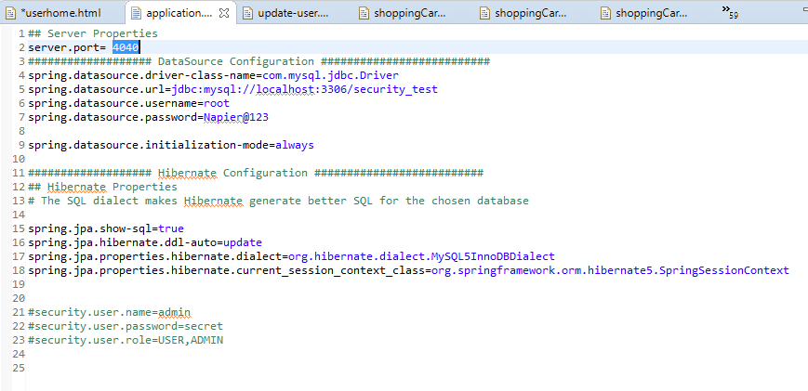

**🡪data.sql**

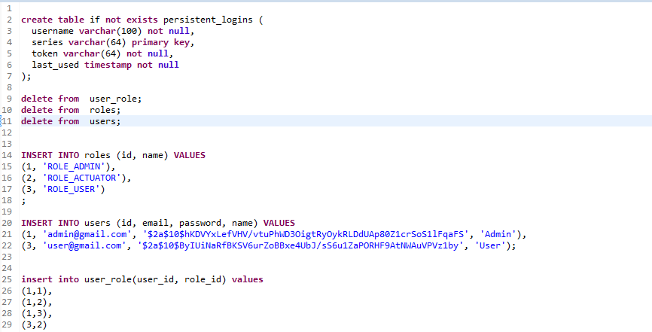

**🡪message.properties**

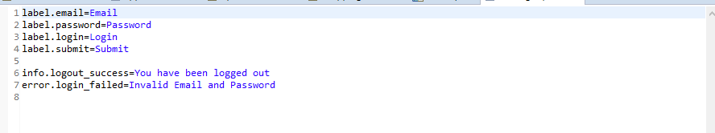

**Outputs- Screenshots**

**Admin Capabilities:-**

**AdminLoginPage with Email and password**

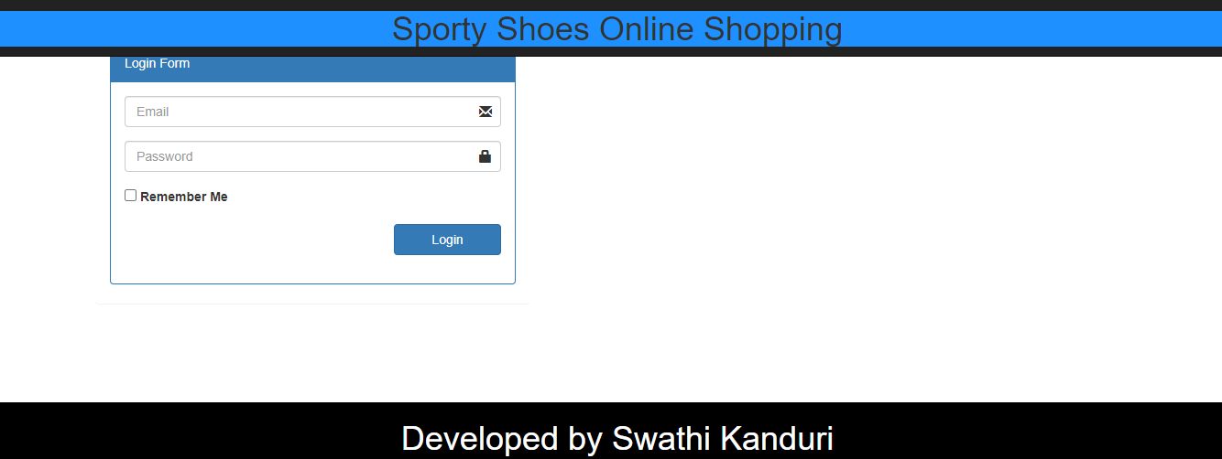

**Admin login details with mail and password**

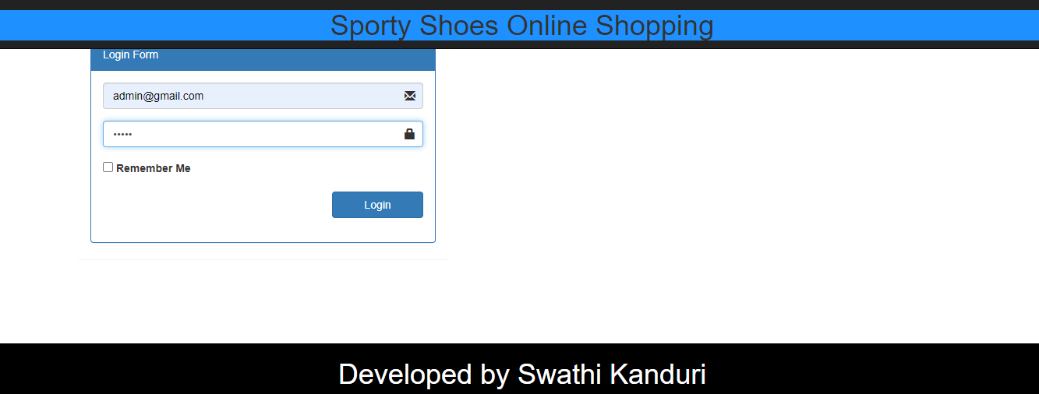

**After successful login-Display user’s List along with users**

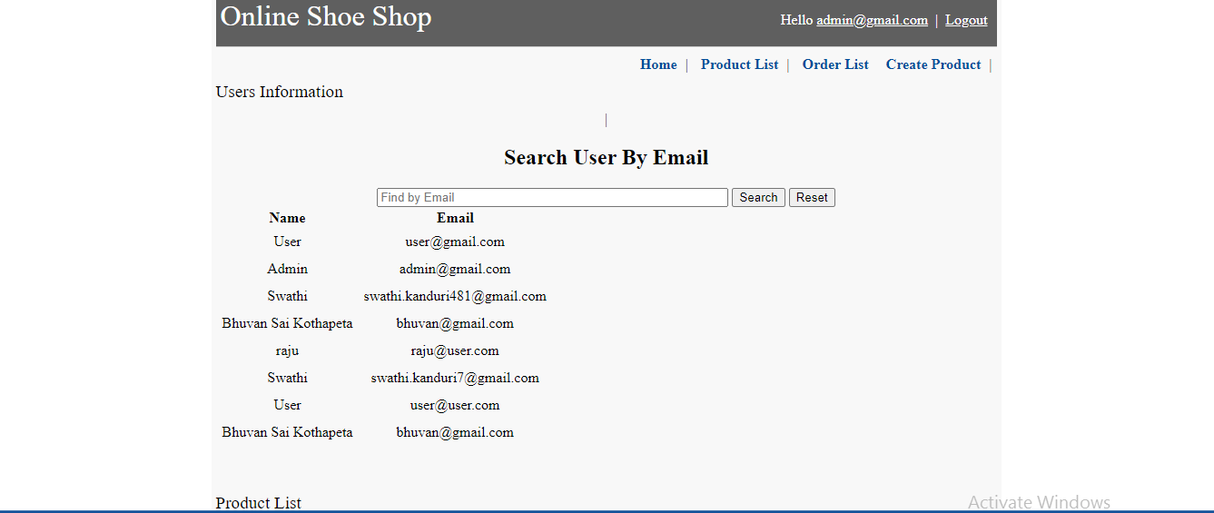

**Search user by email**

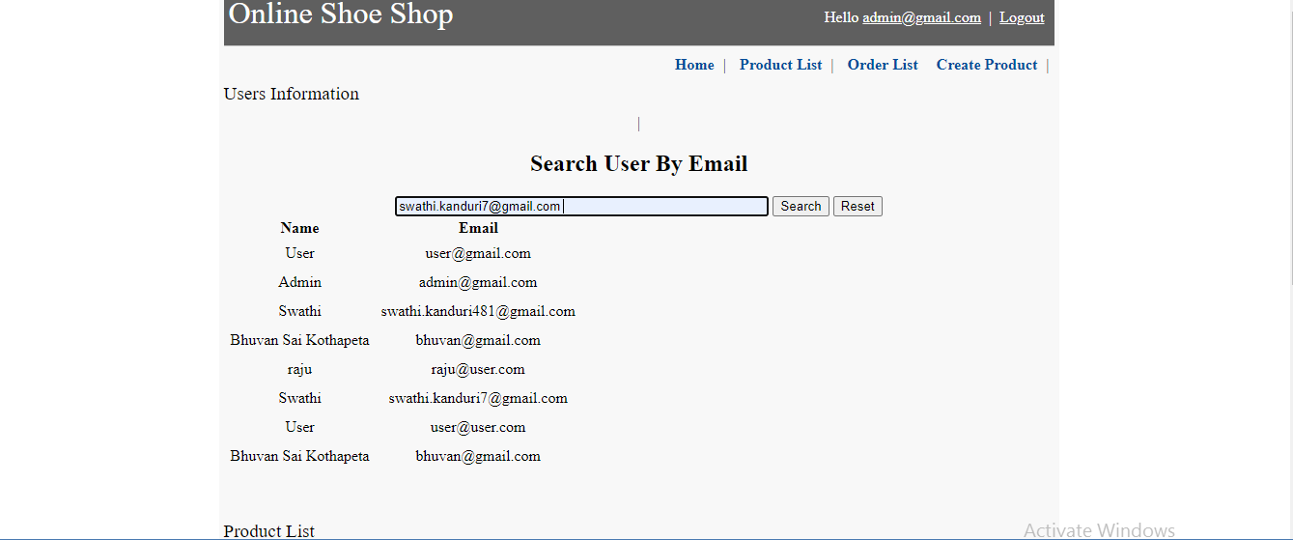

**User information**

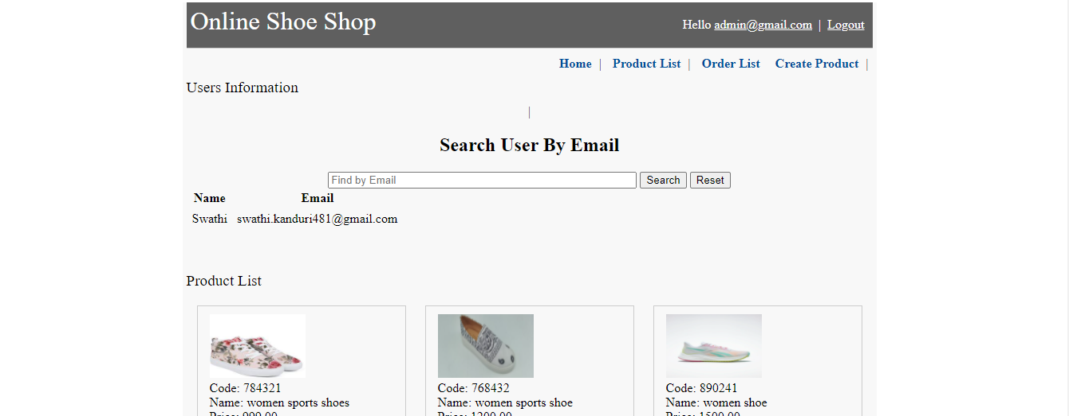

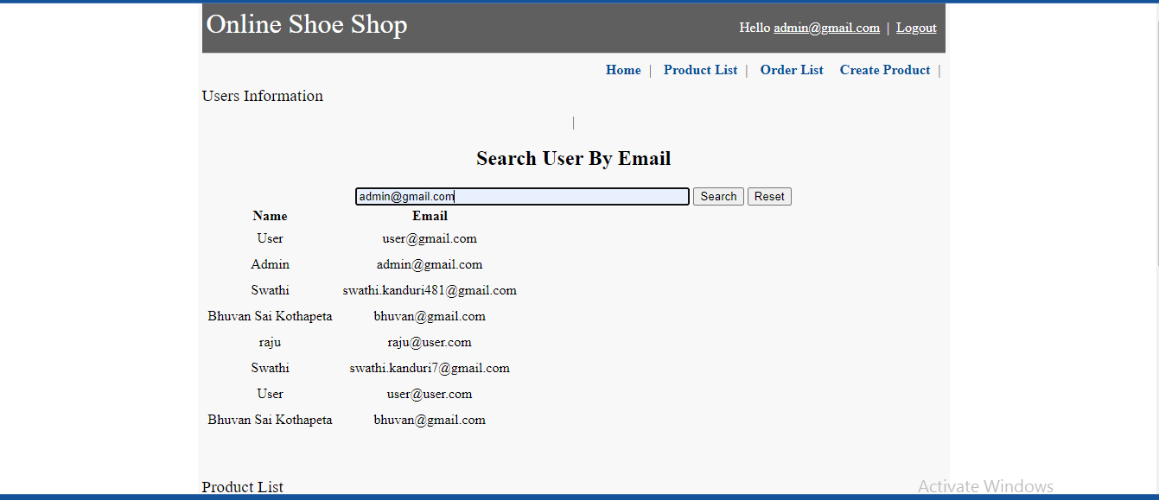

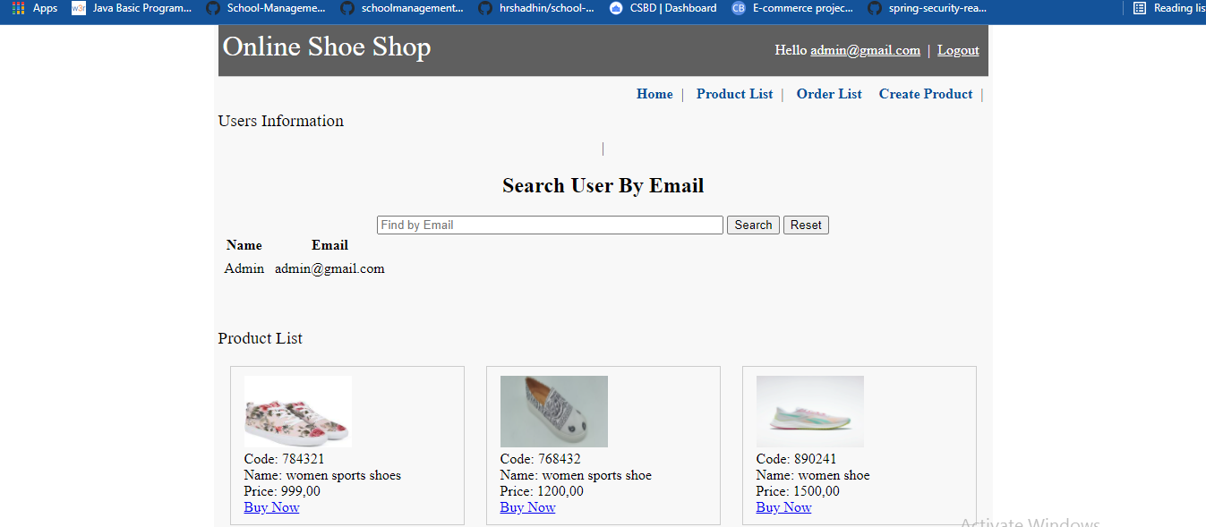

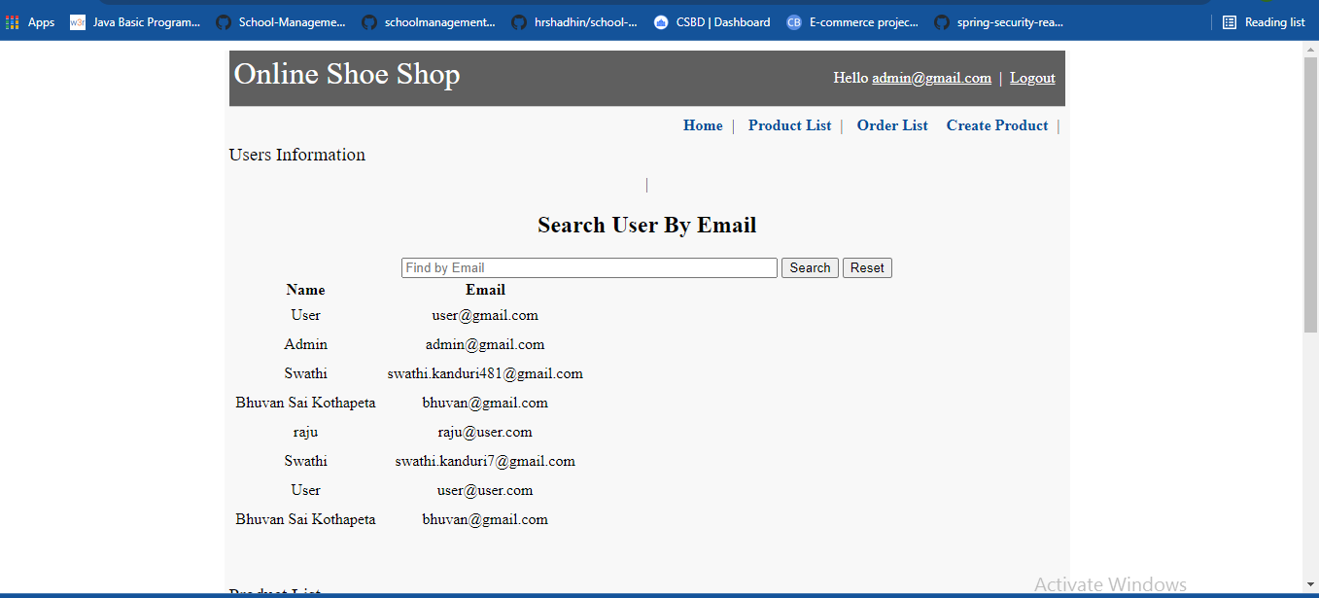

**If click on product list**

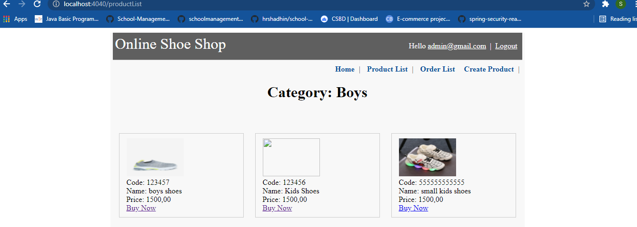

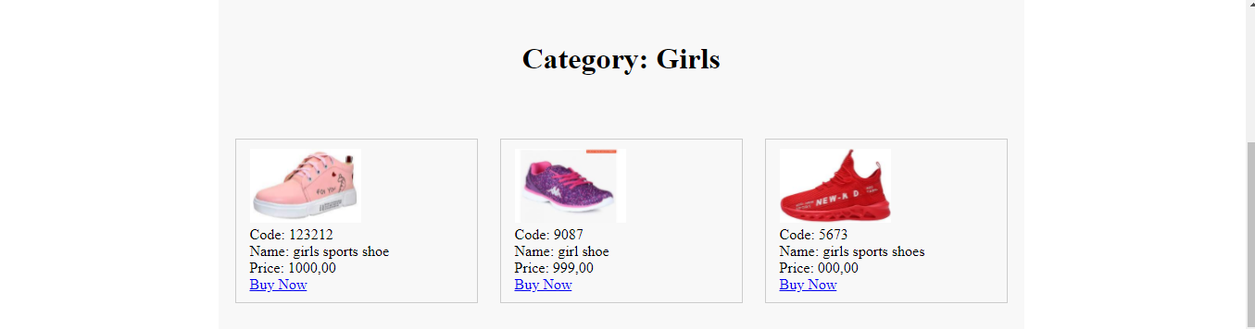

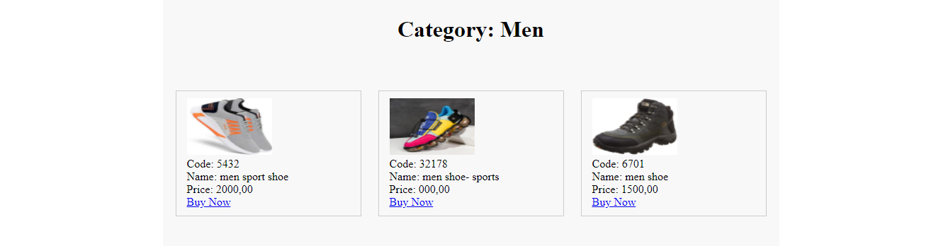

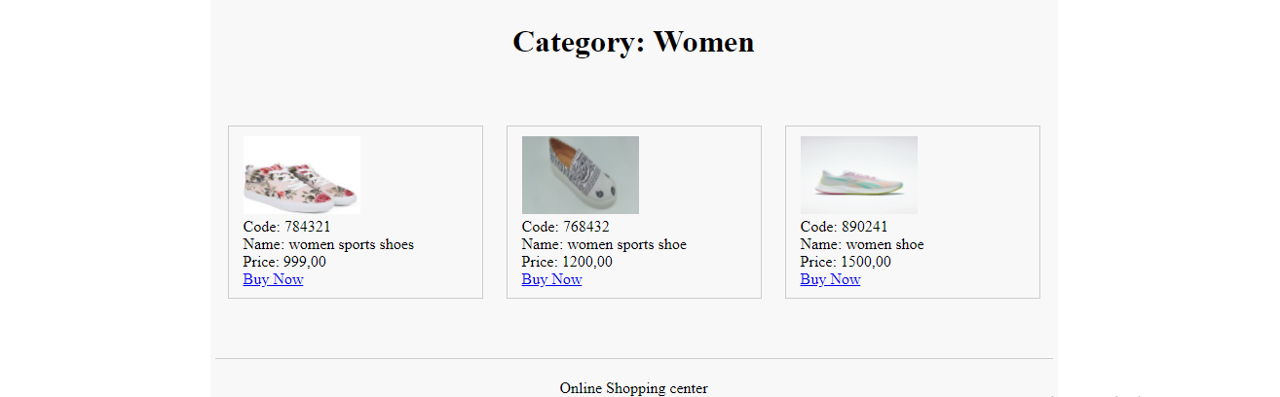

**Click on order list**

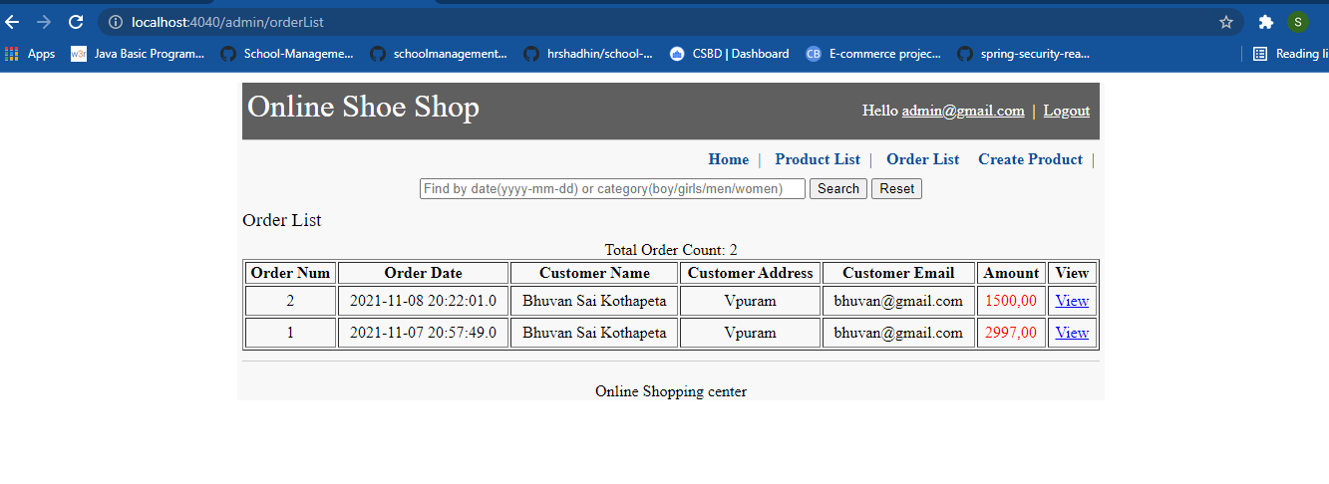

**Search order’s by Date**

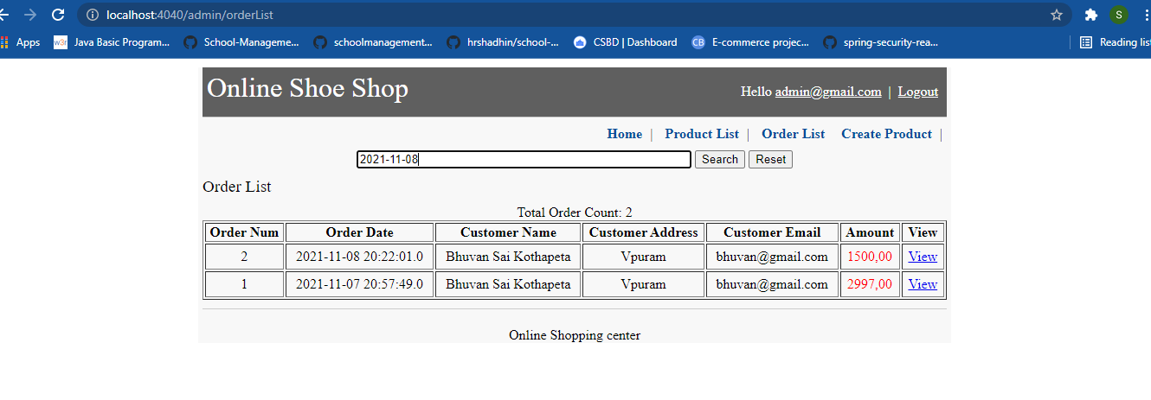

**Search Result for above**

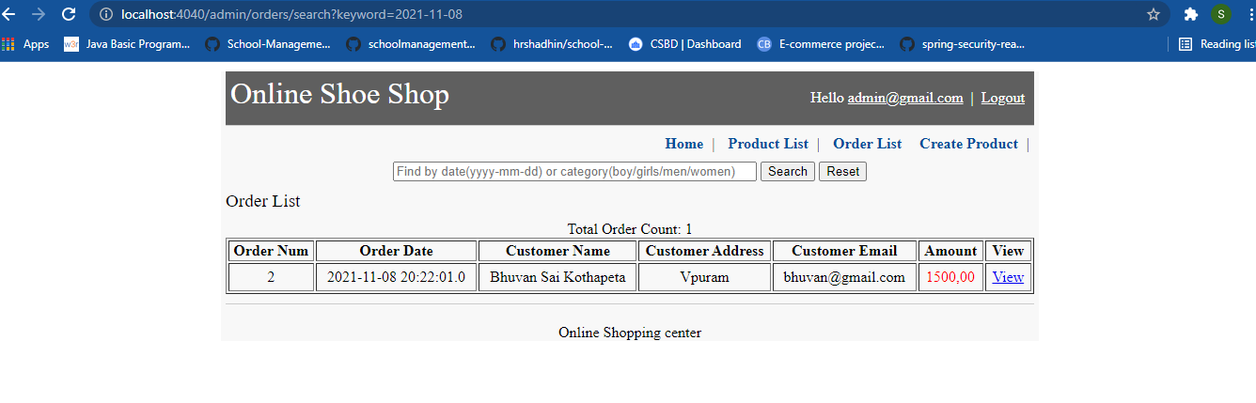

**Search Order’s by category(ex-boy,girl,men & women)**

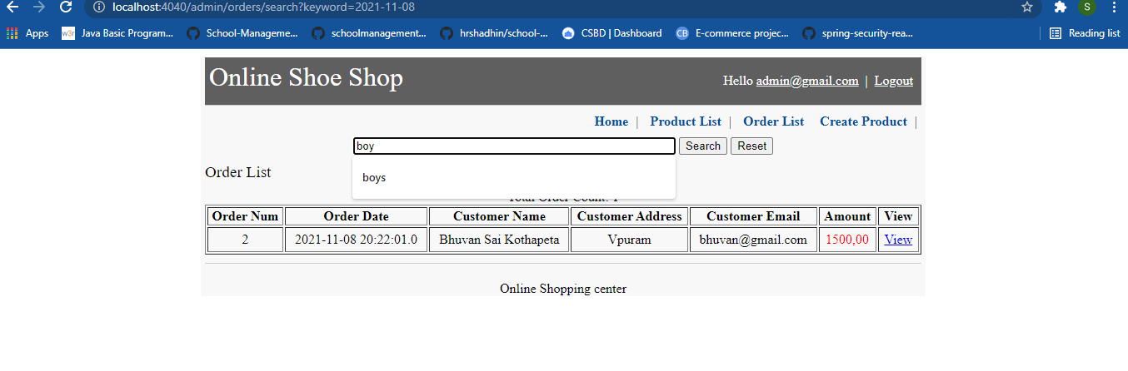

**Create product**

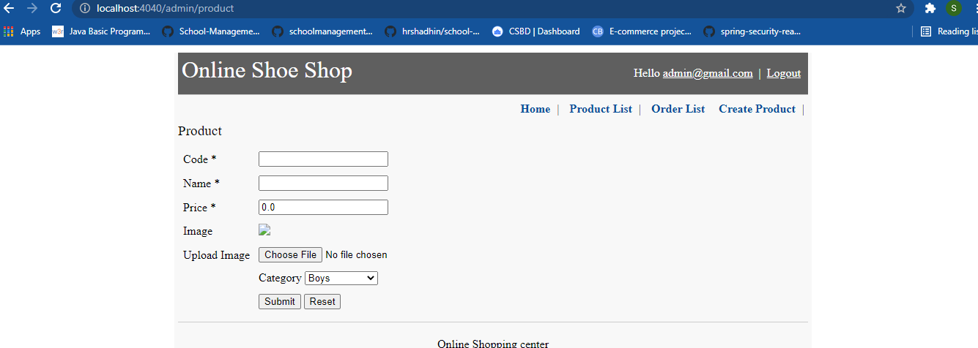

**Enter the product details**

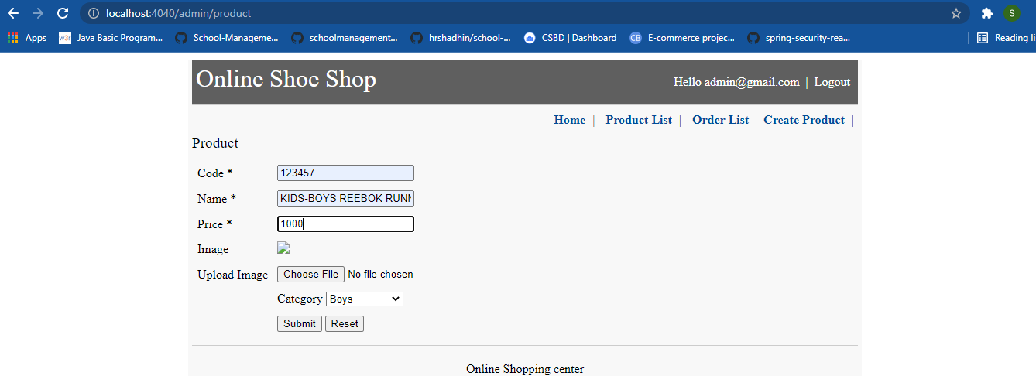

**User Capabilities**

**Home page to click on signup for new user**

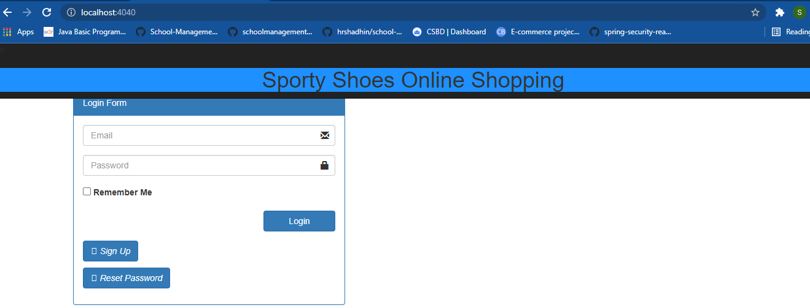

**Provide user details to register in the below form**

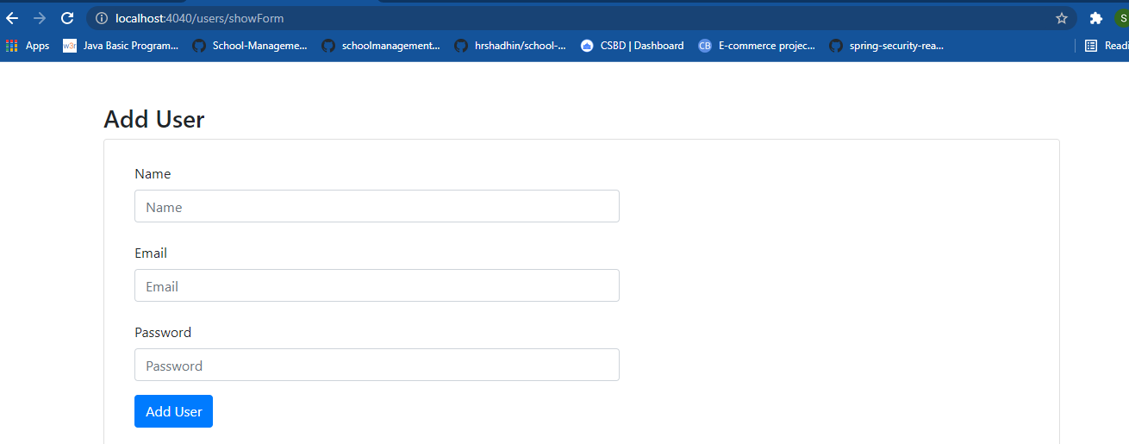

**Fill the details to register**

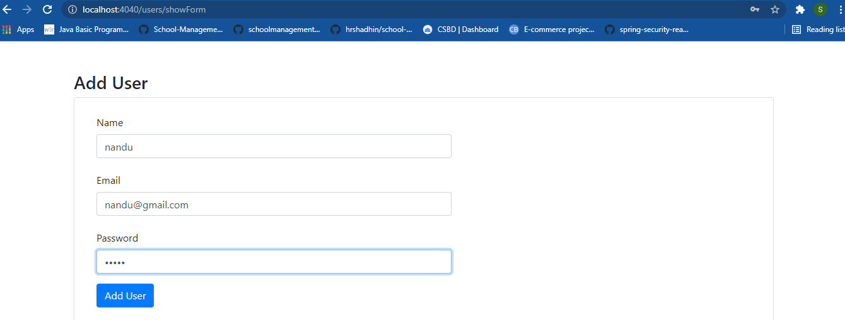

**After successful registration it will redirect to login page**

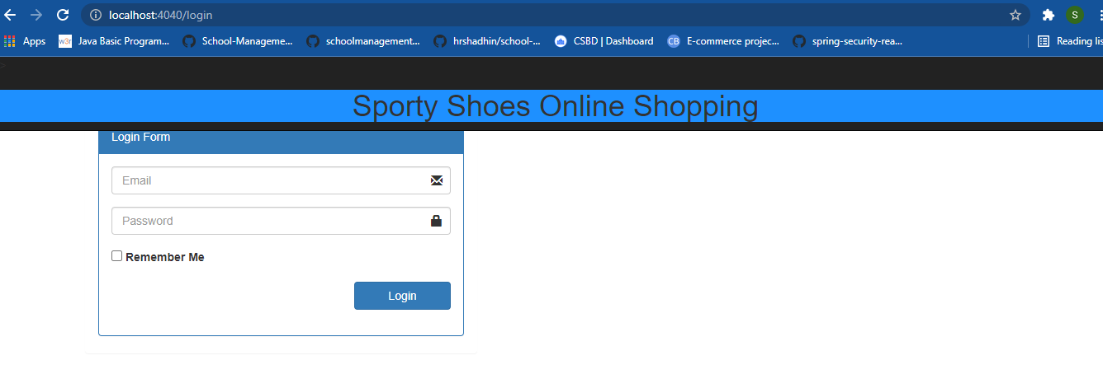

**After successful user login**

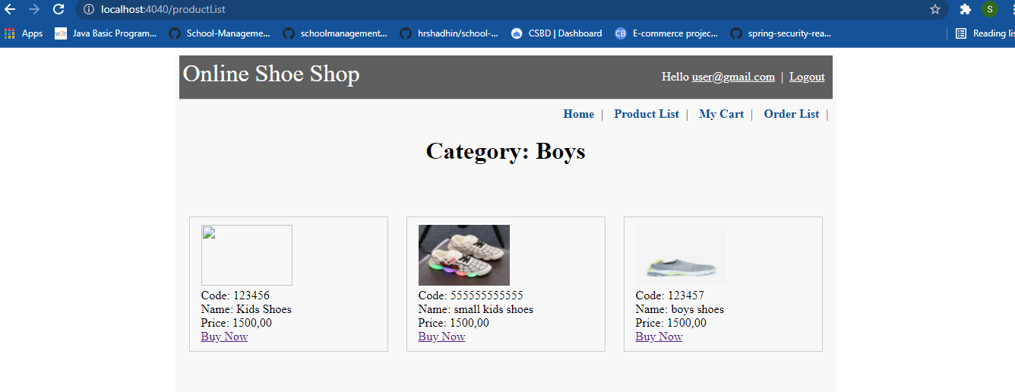

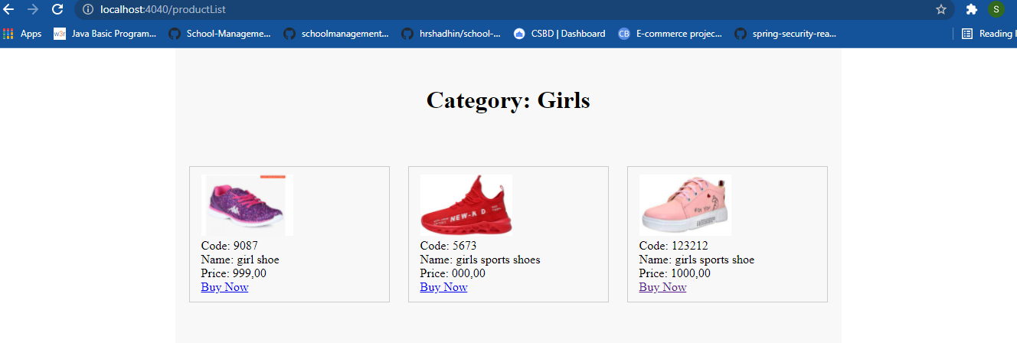

**User can Buy the product by clicking on buy now**

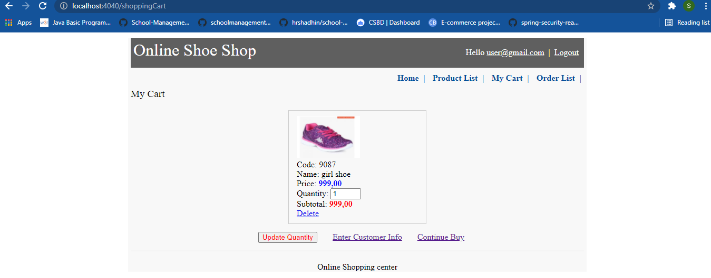

**If user wants to Update the quantity**

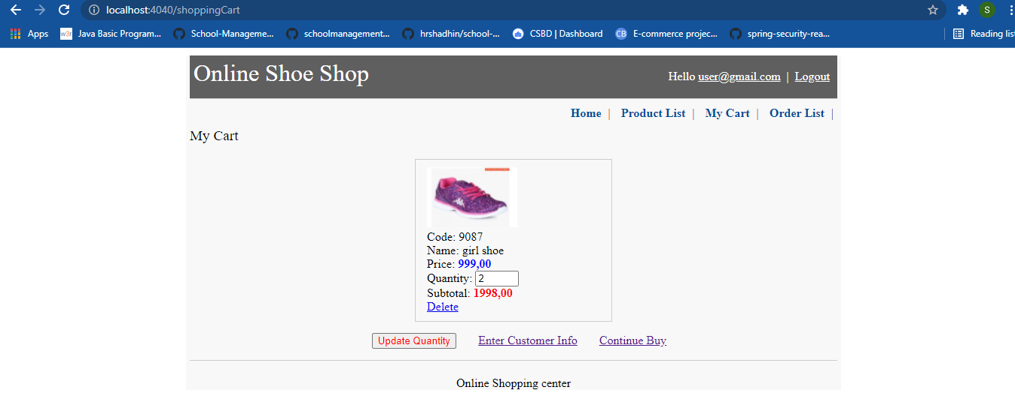

**customer information form**

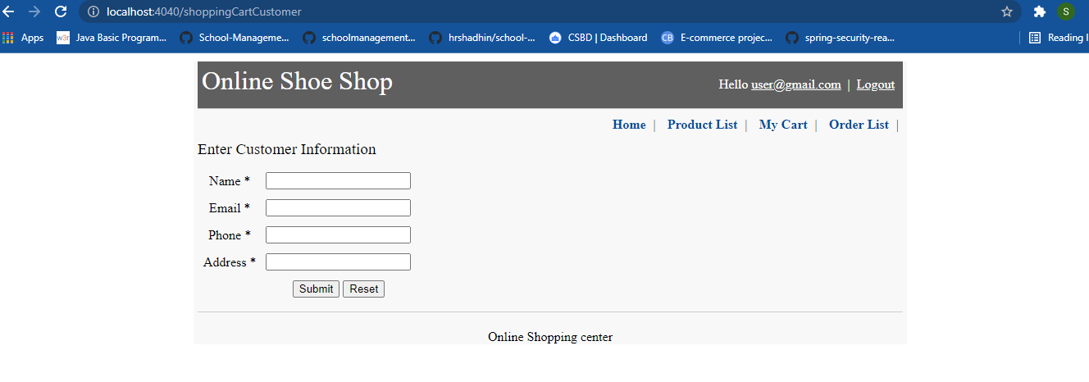

**Enter the customer information**

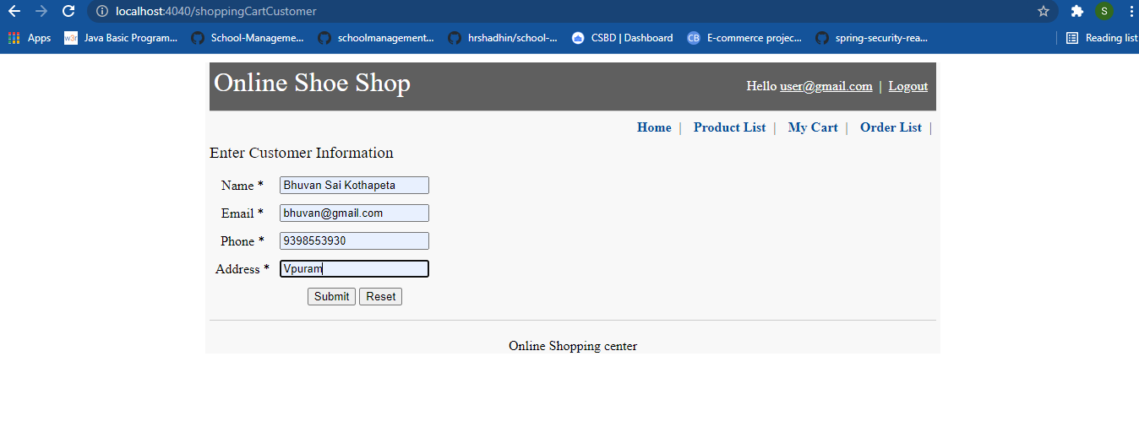

**Confirmation**

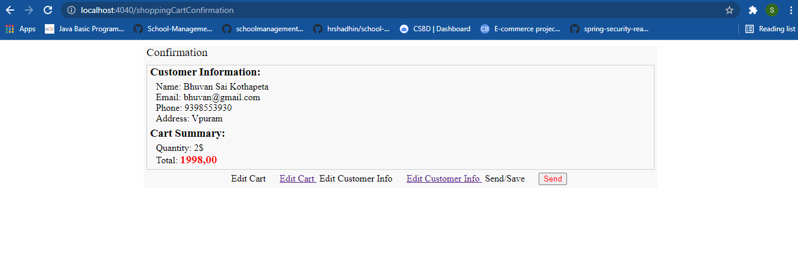

**If user clicks on edit cart**

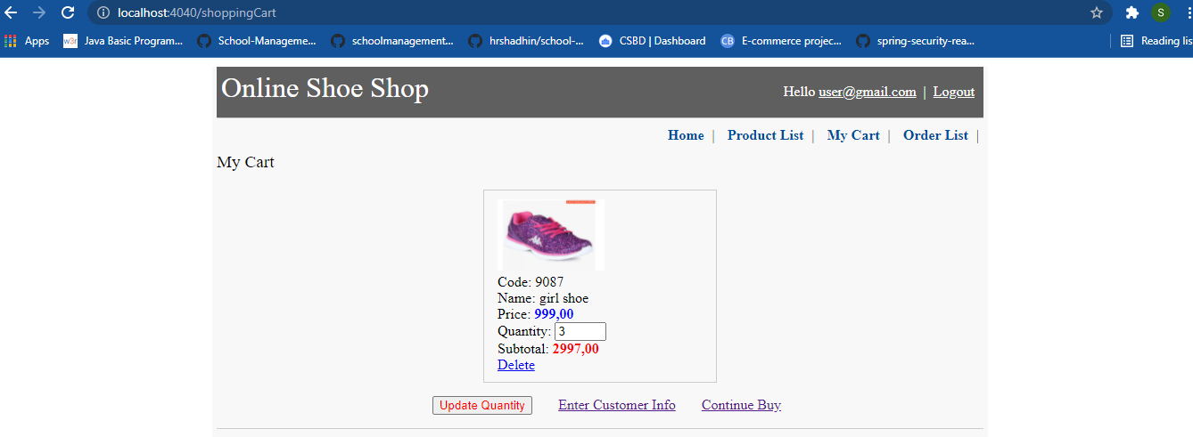

**If user clicks on edit customer info**

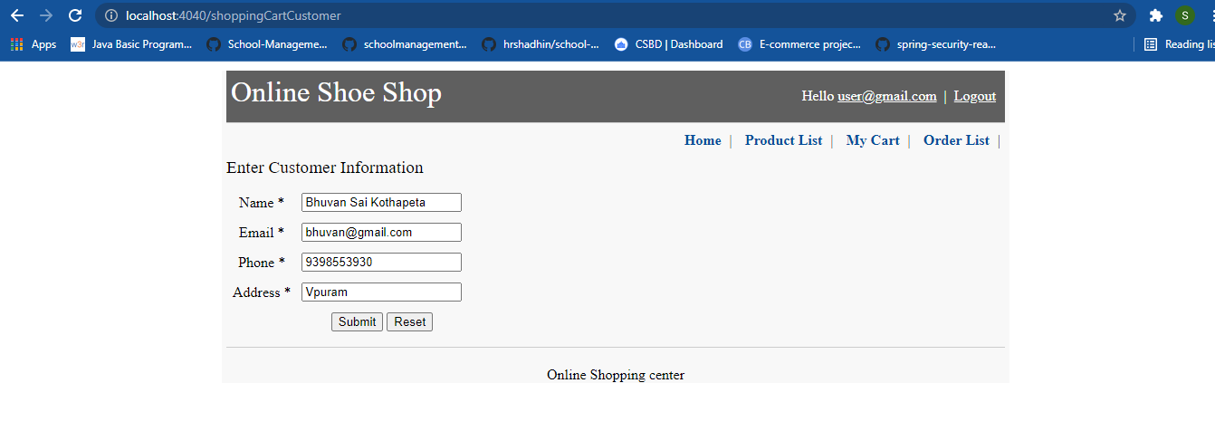

**If user click on send option**

